嘉義市101年度提升英語學習成效計畫 英語歌唱比賽- 國小組
精忠國小: Do Re Mi、A Laving Father
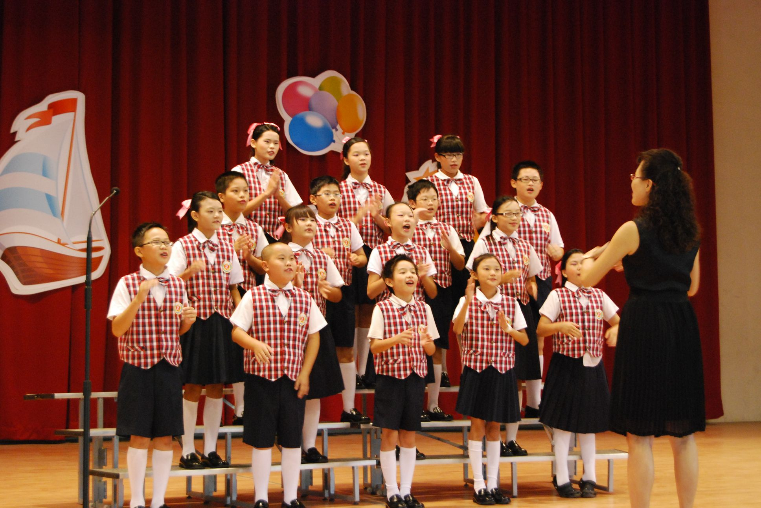

民族國小: Sing、What Makes You Beautiful
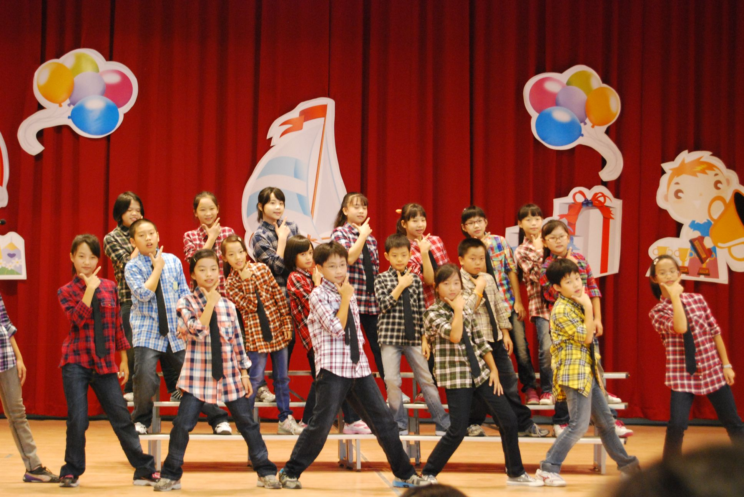

嘉北國小: Sing、Yellow Submarine
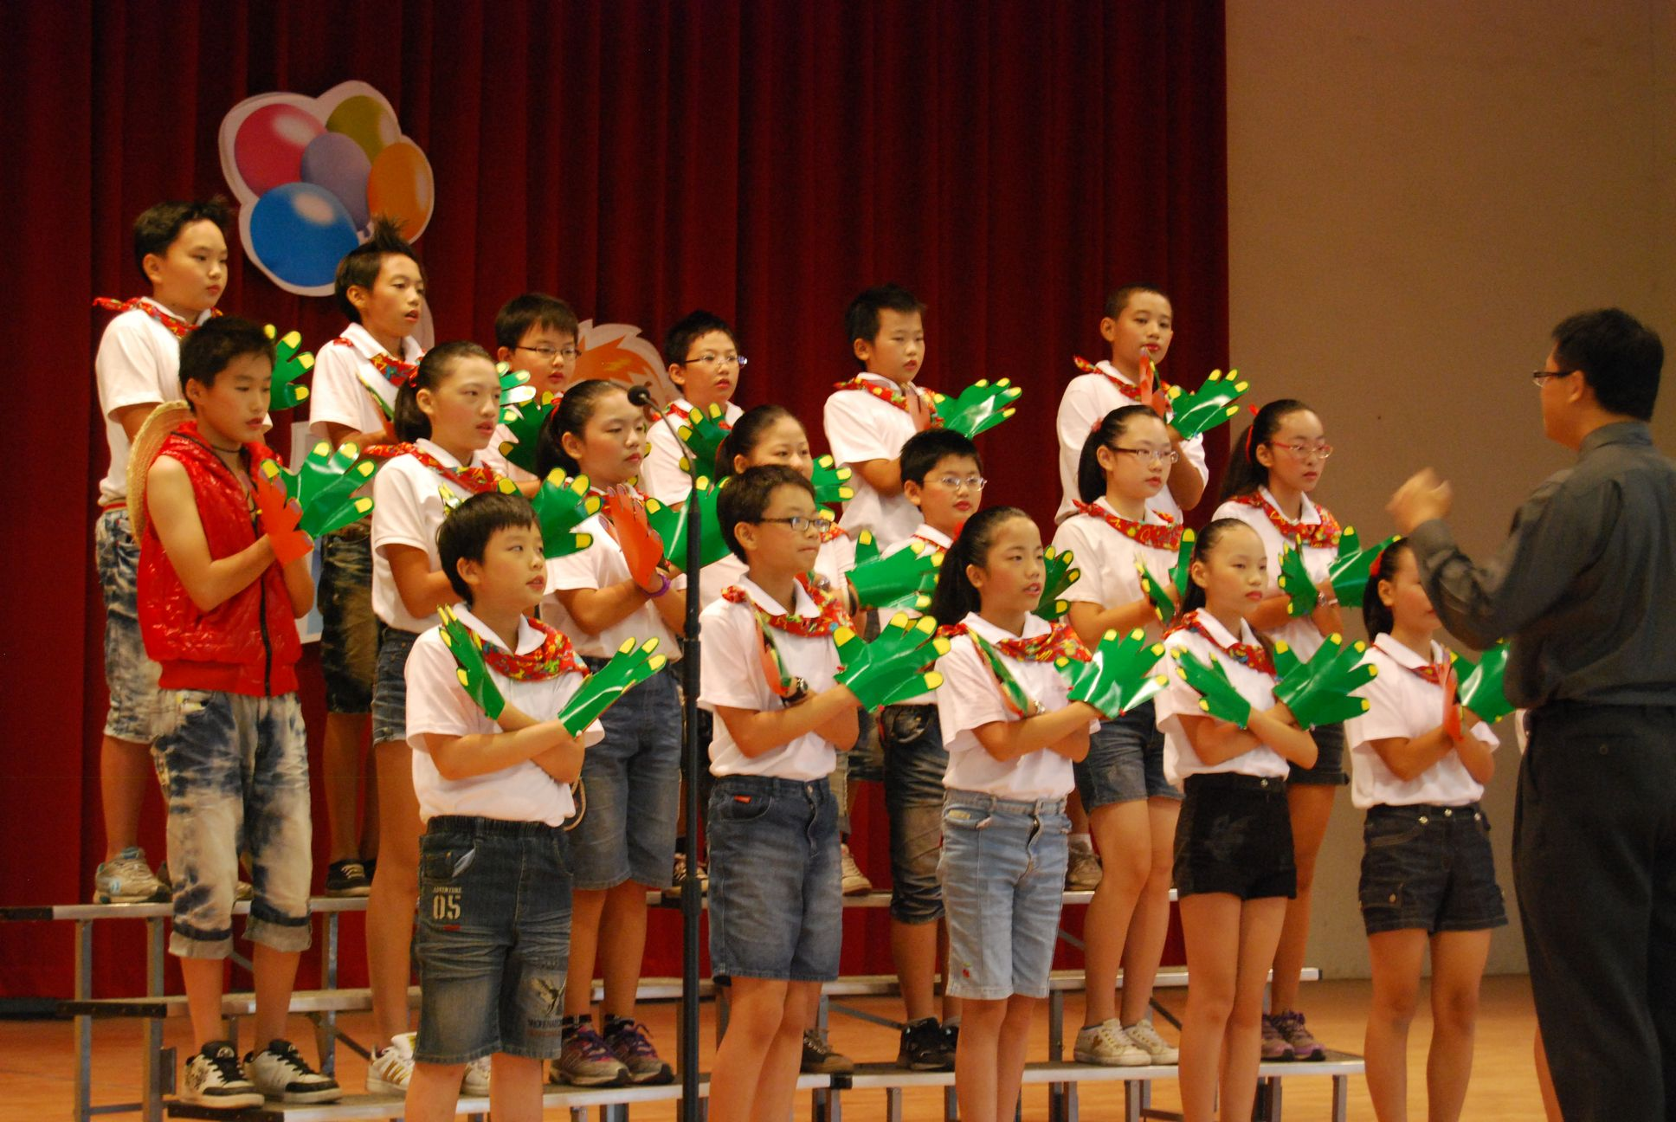

蘭潭國小: Do Re Mi、Proud of You
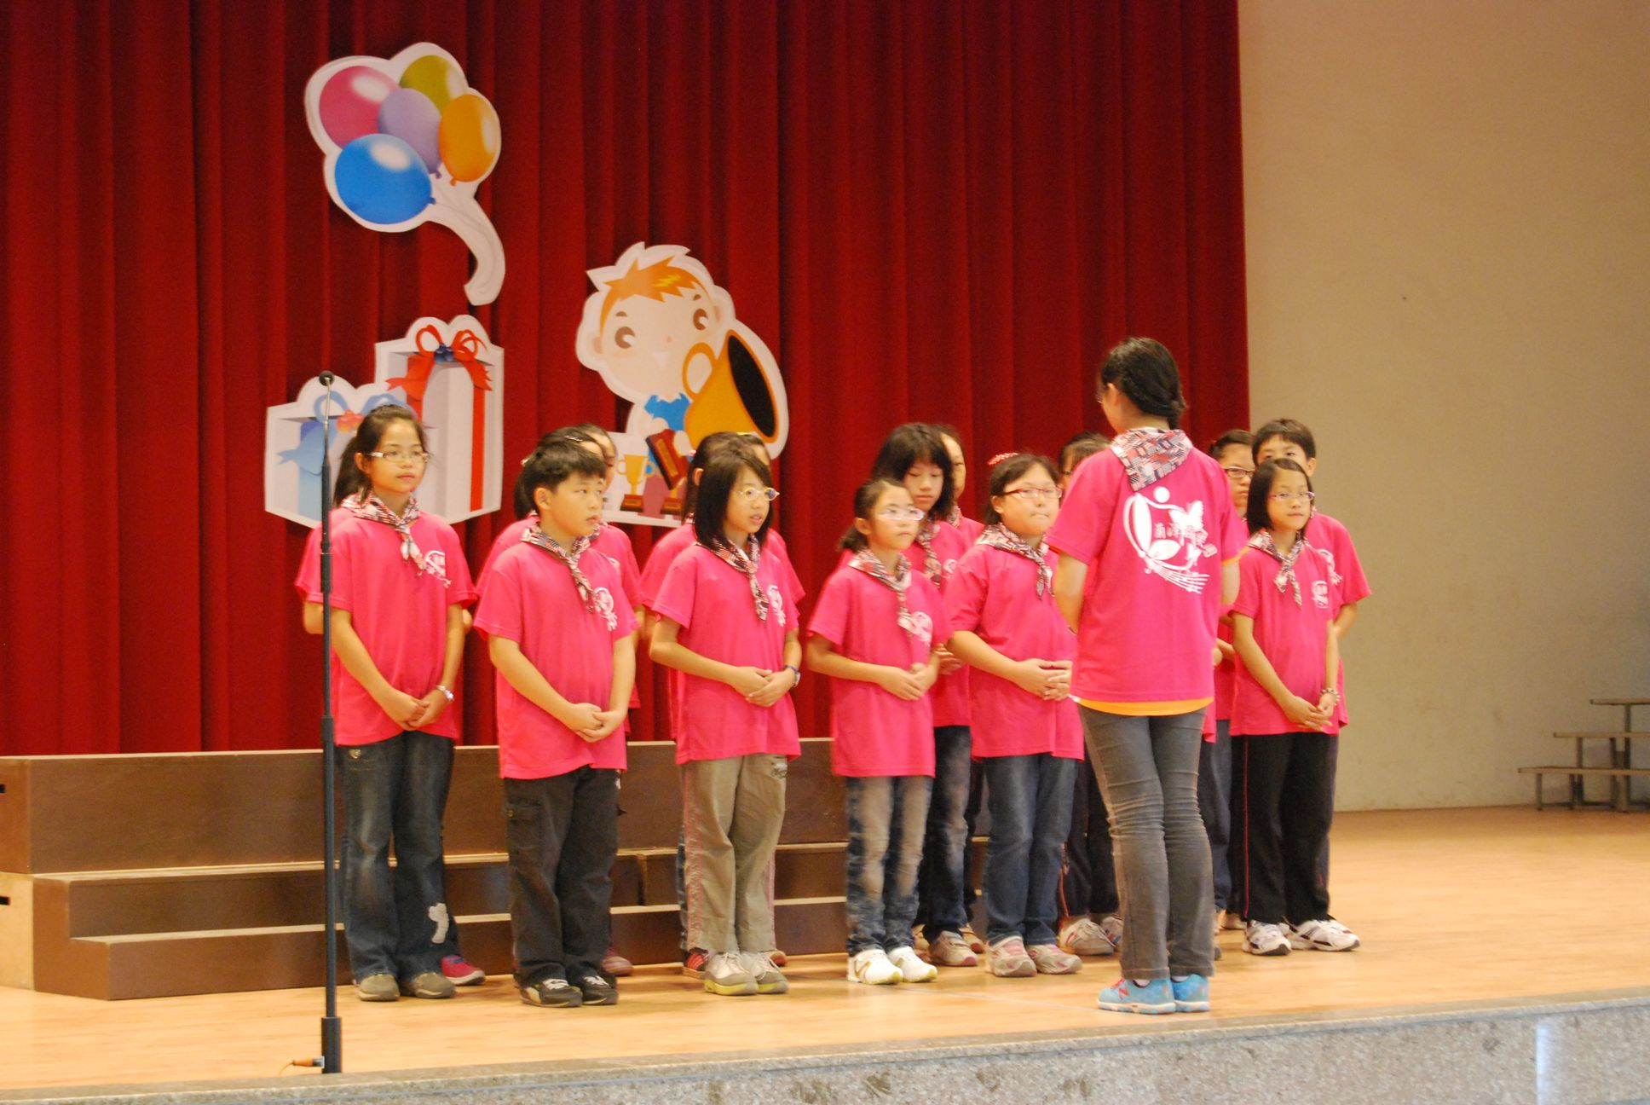

北園國小: Sing、Baby

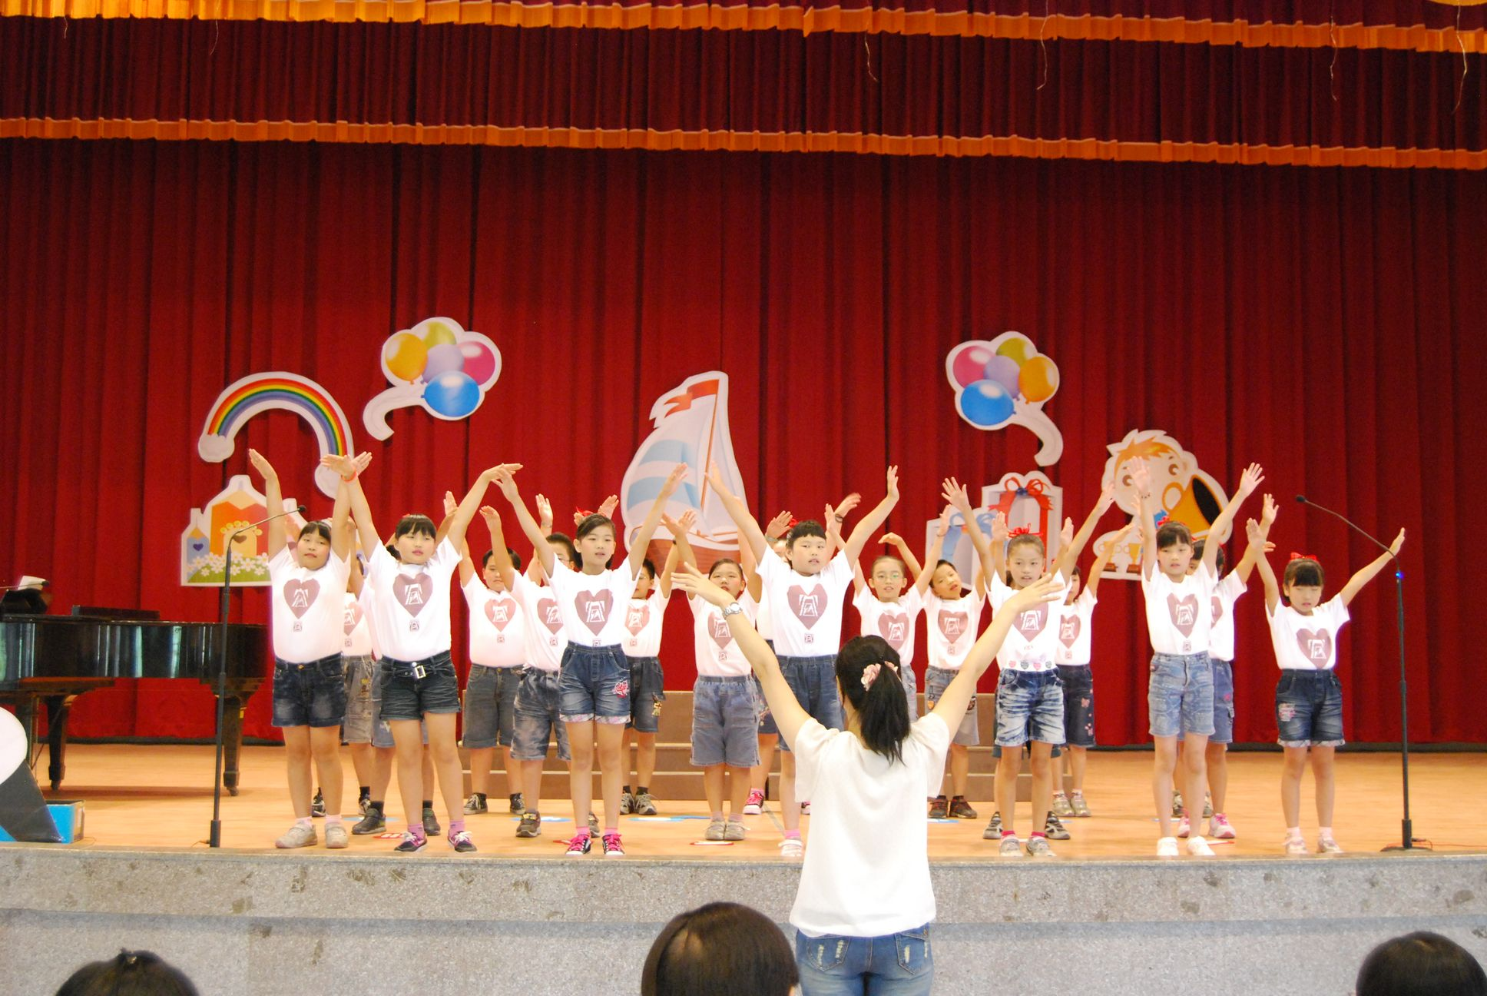

文雅國小: Sing、We Are the World
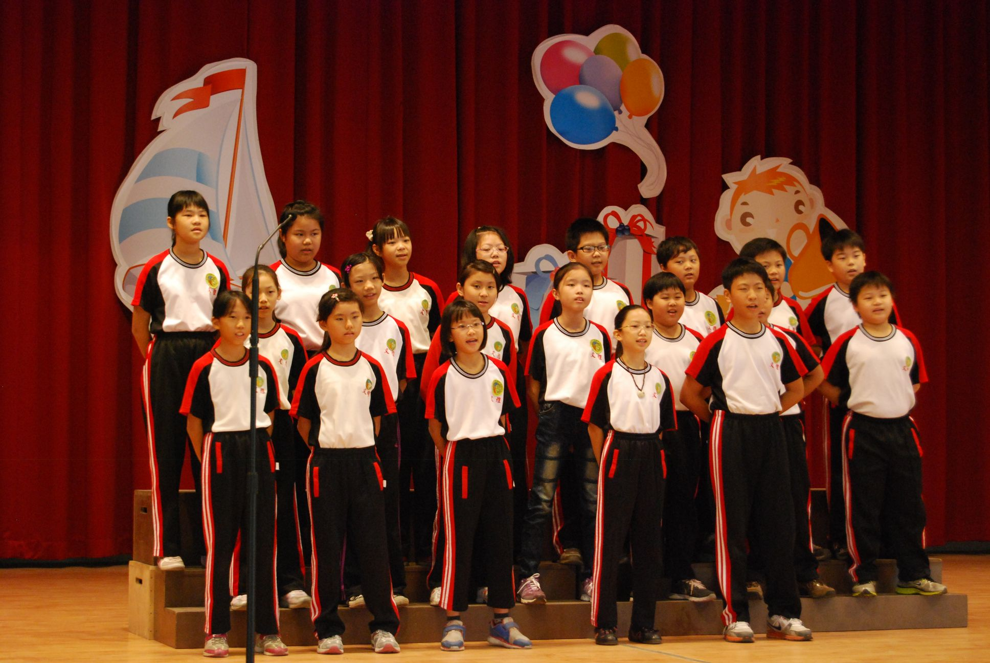

育人國小: Sing、Eternal Flame

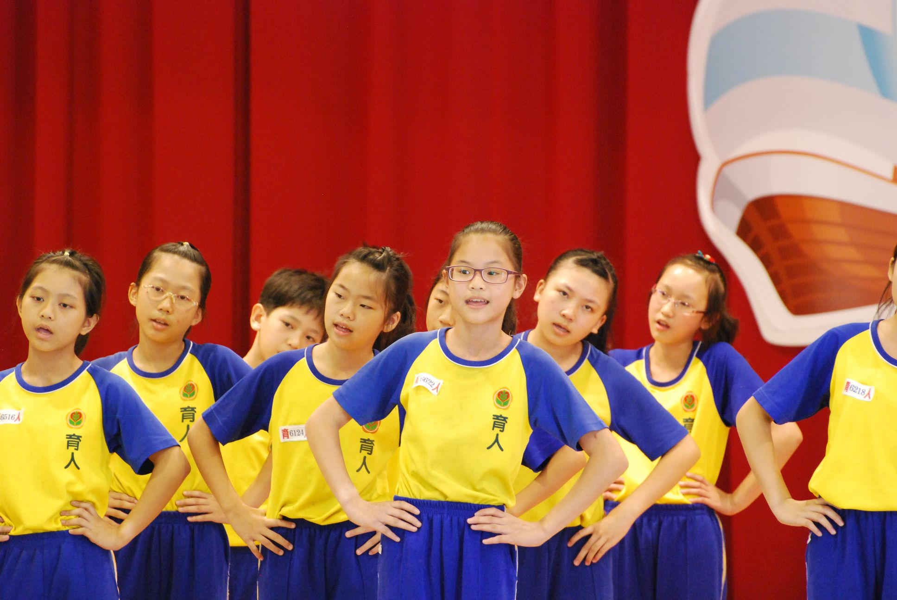

大同國小: Sing、Any Dream Will Do
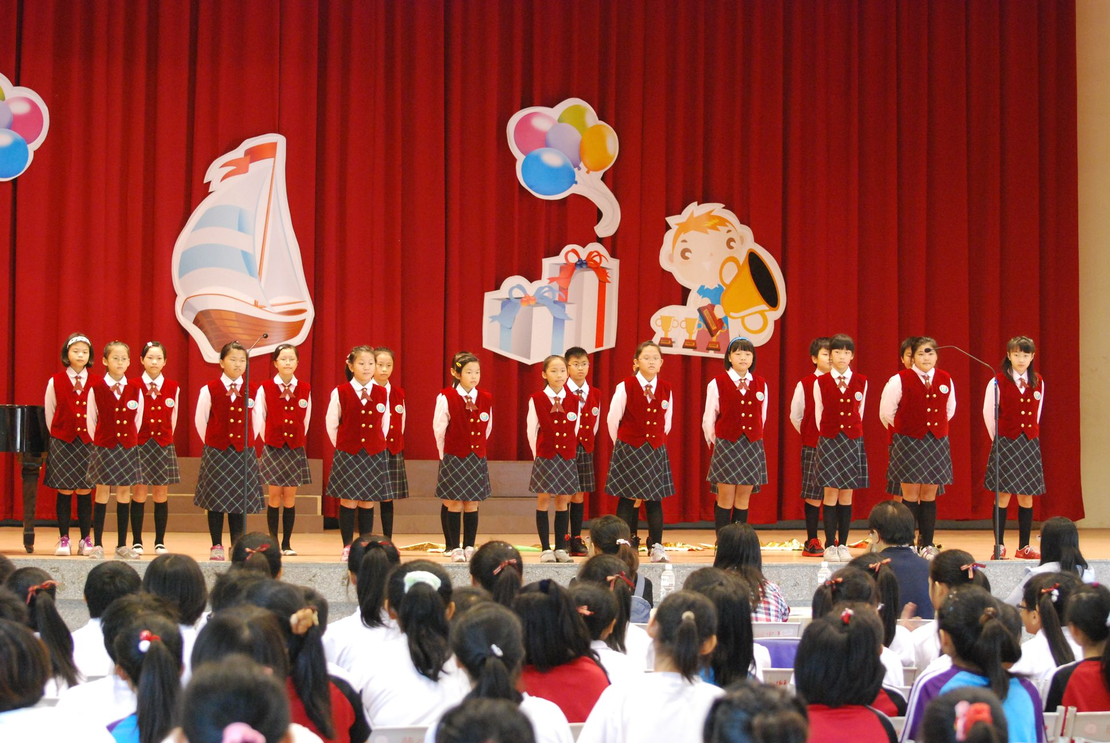

宣信國小: Sing、Beautiful Sunday
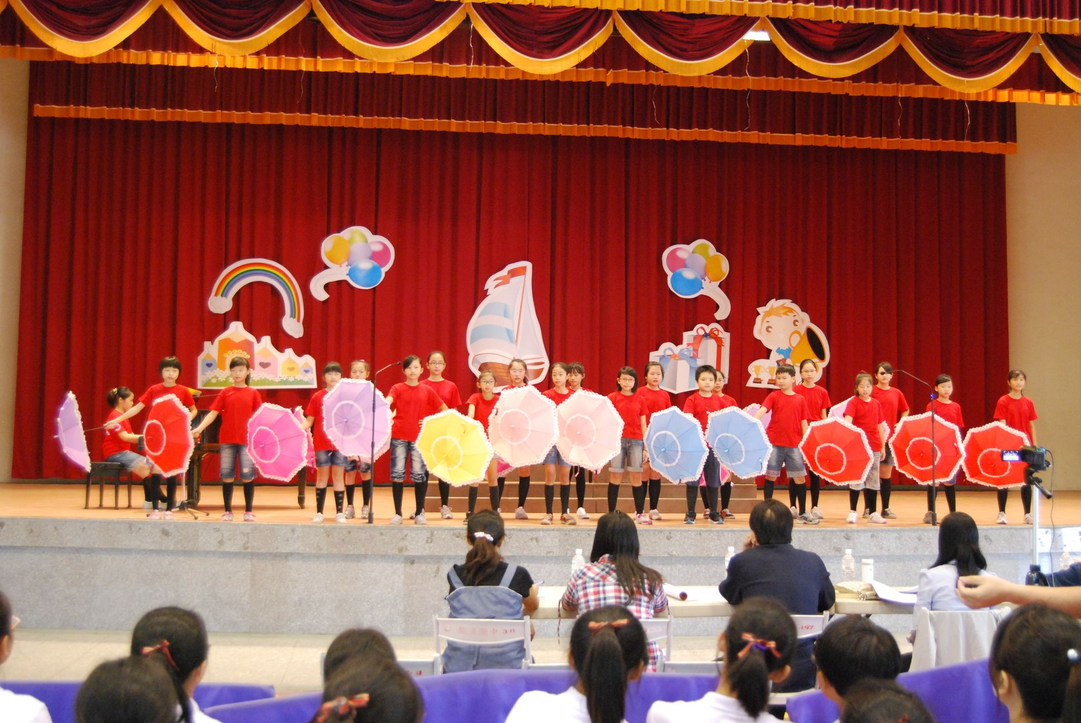

興安國小: Do Re Mi、Beautiful Sunday

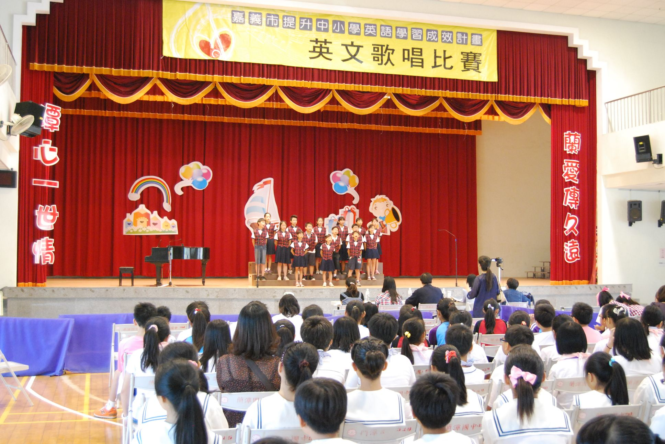

博愛國小: Do Re Mi、Take These Wings
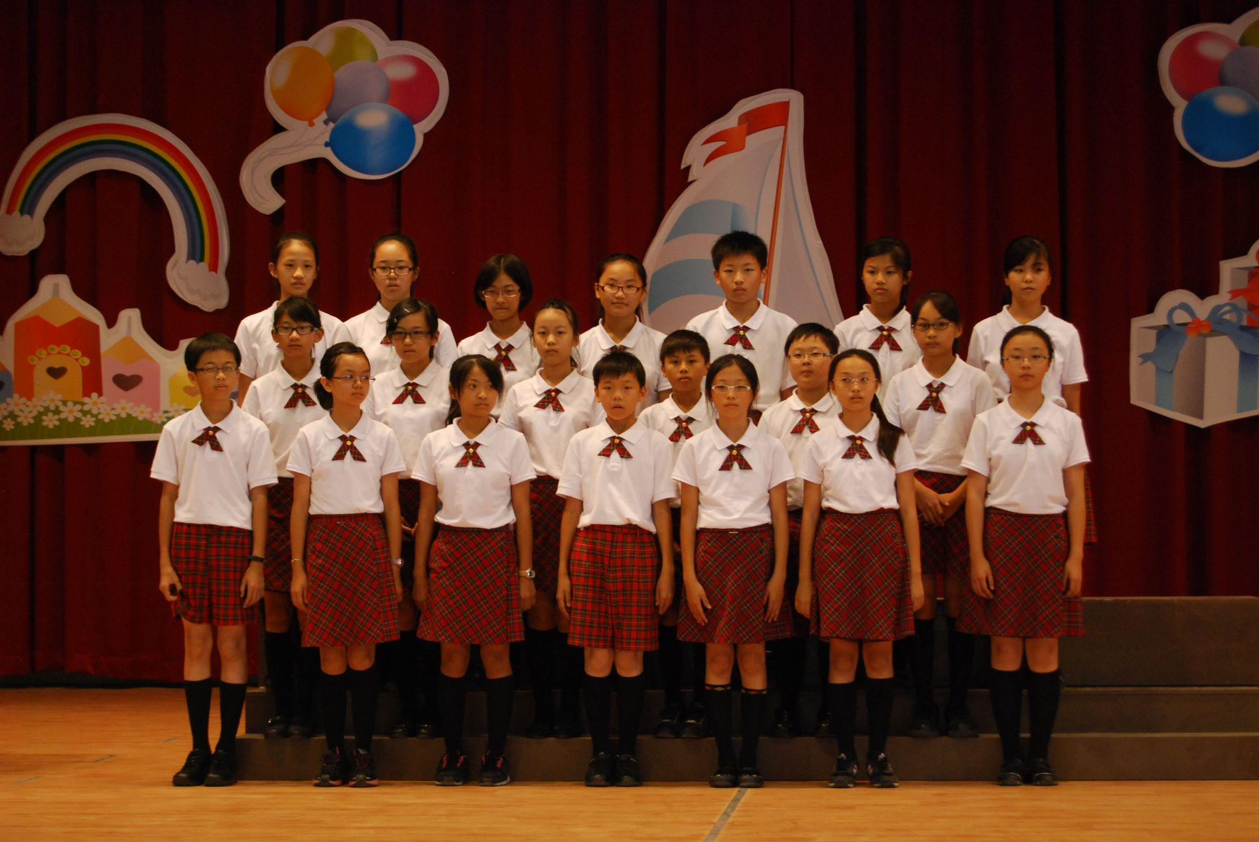

崇文國小: Do Re Mi、The World Is Yours

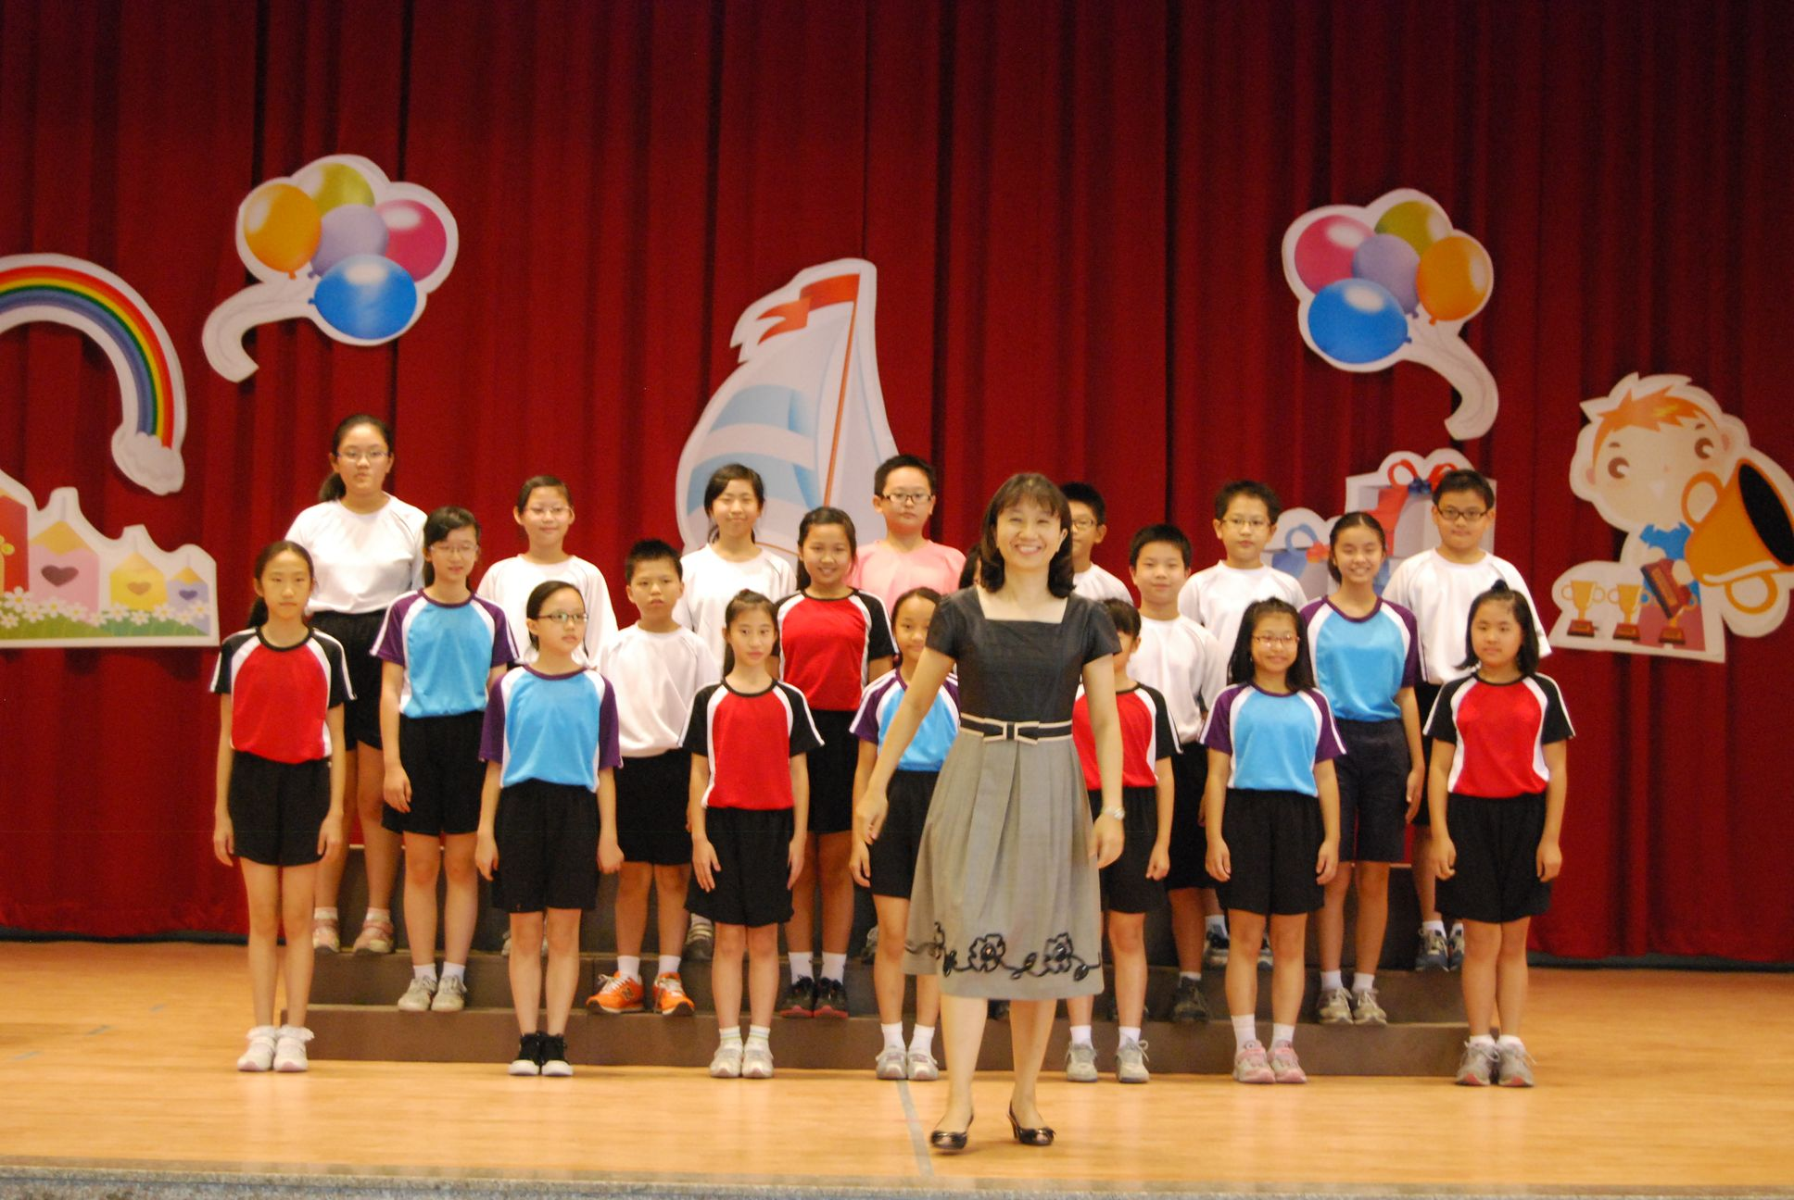

世賢國小: Ｄo Re Mi、The End of the World
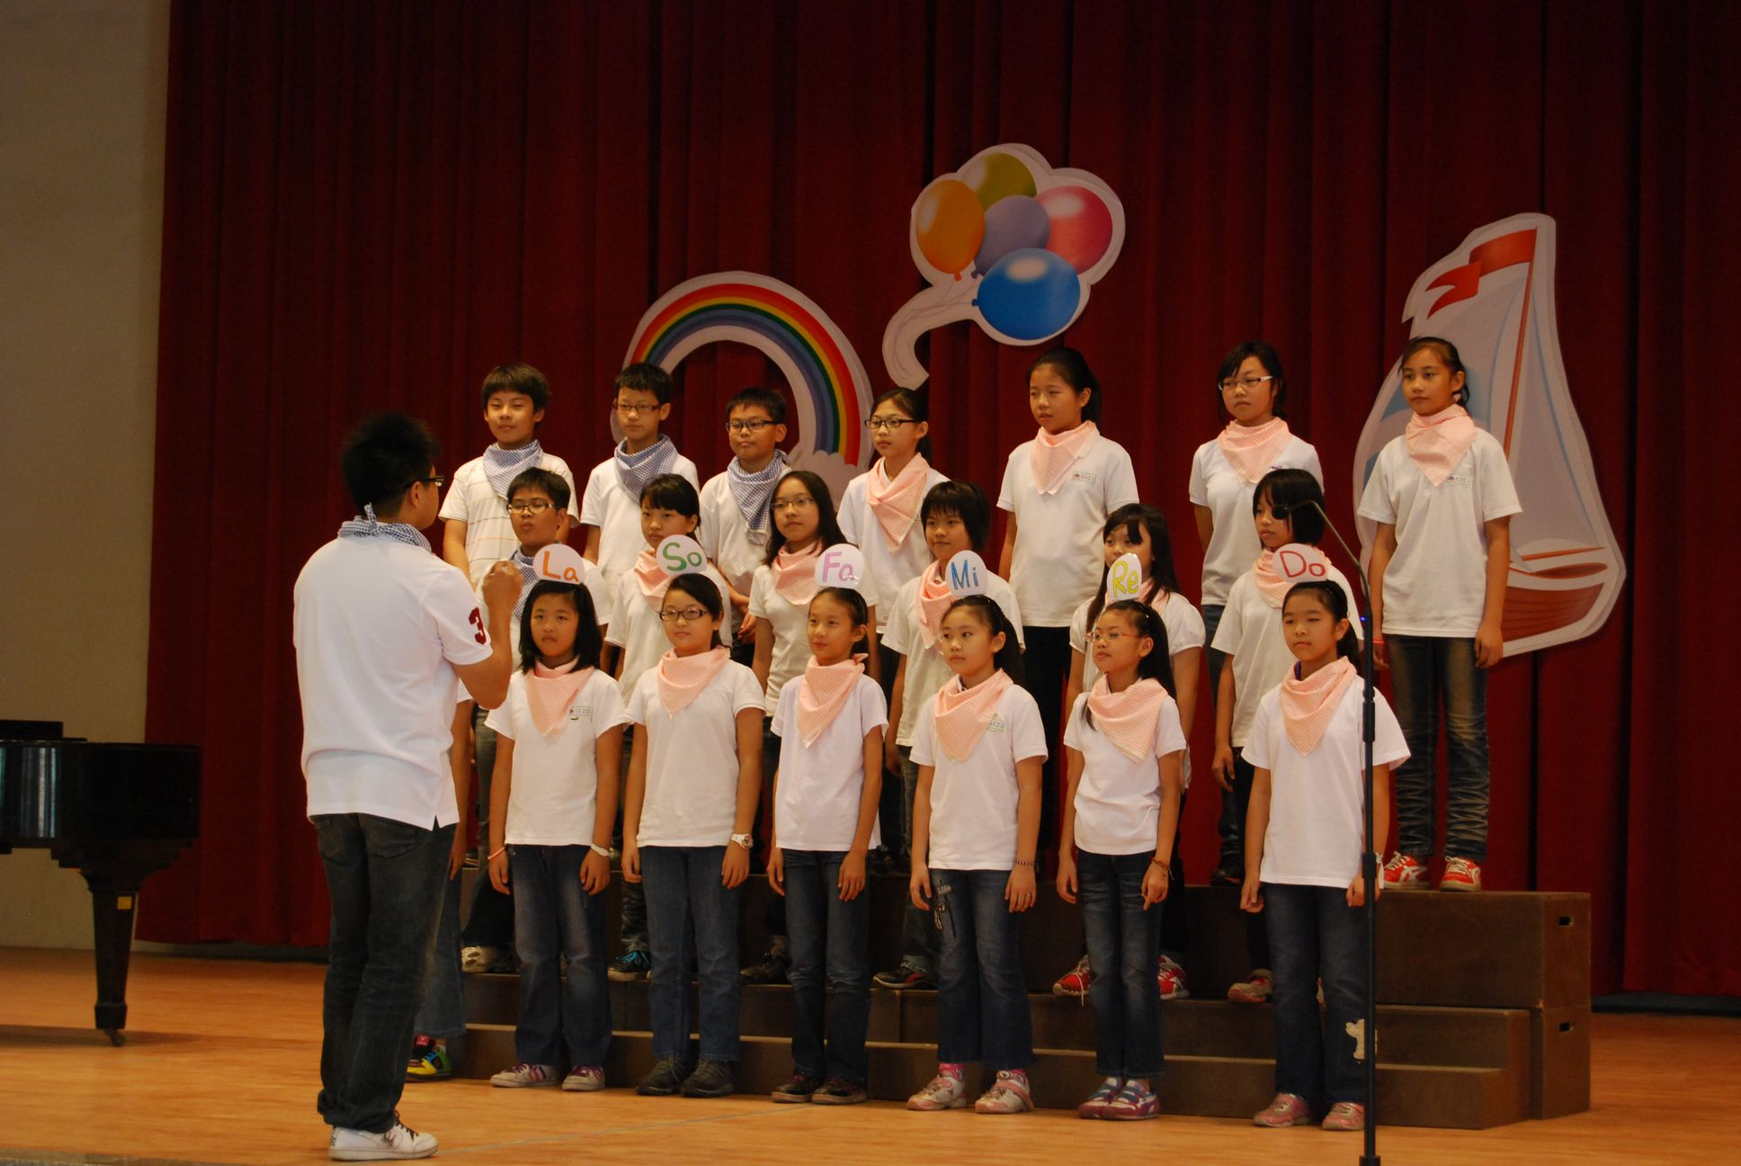

志航國小: Do Re Mi、Edelweiss
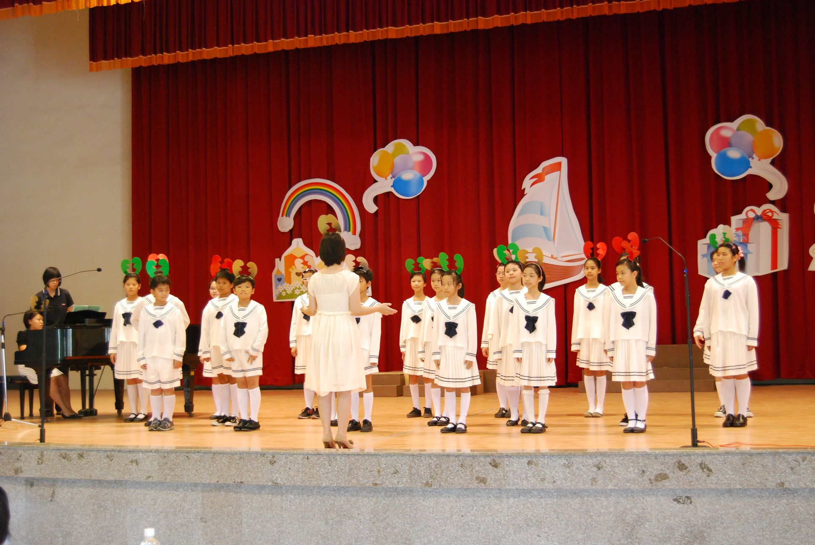

僑平國小: Sing、Shalalalala

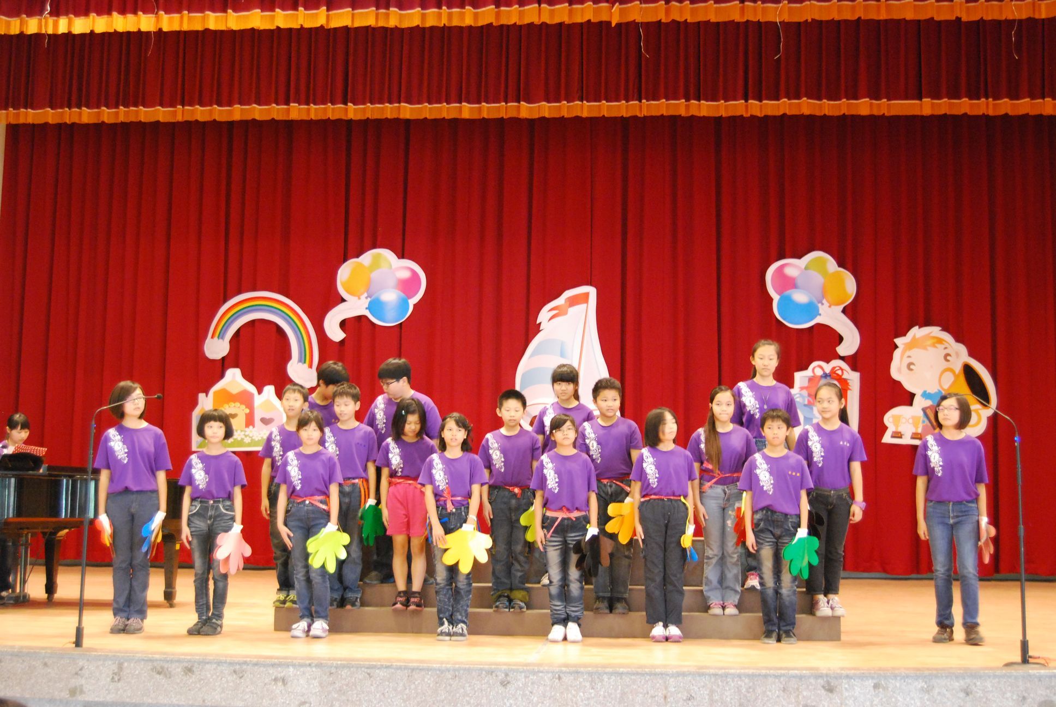

港坪國小: Do Re Mi、Edelweiss
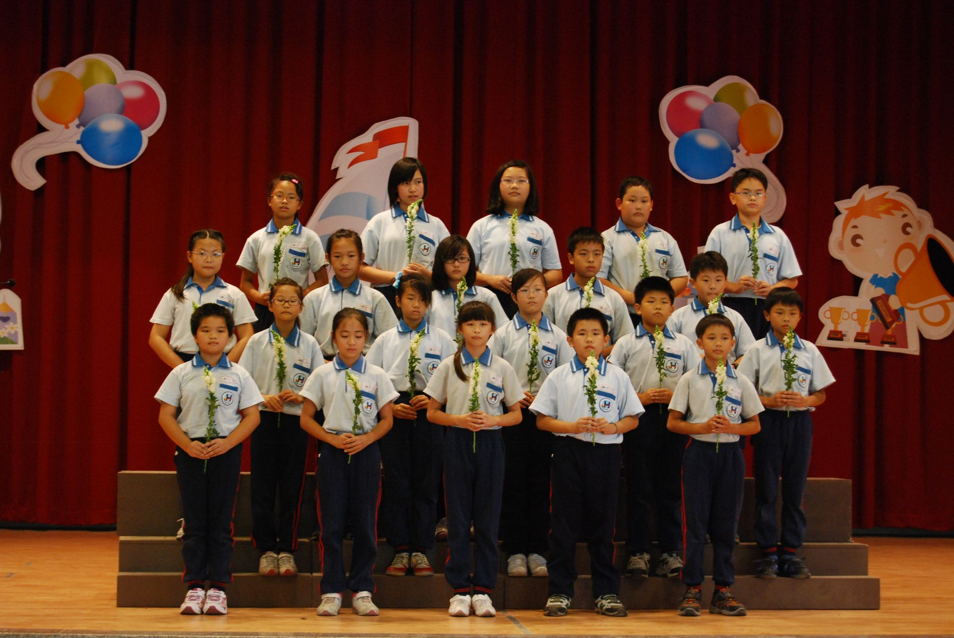

垂楊國小: Do Re Mi、Beautiful Sunday
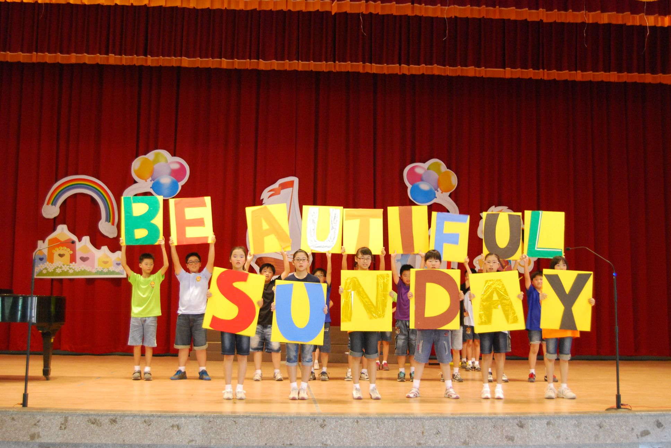

興嘉國小: Do Re Mi、To Where You Are
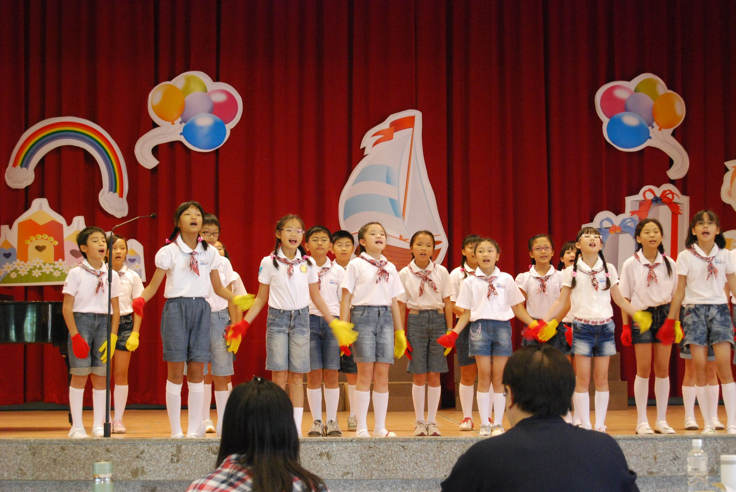

林森國小: Sing、Don’t Cru Joni
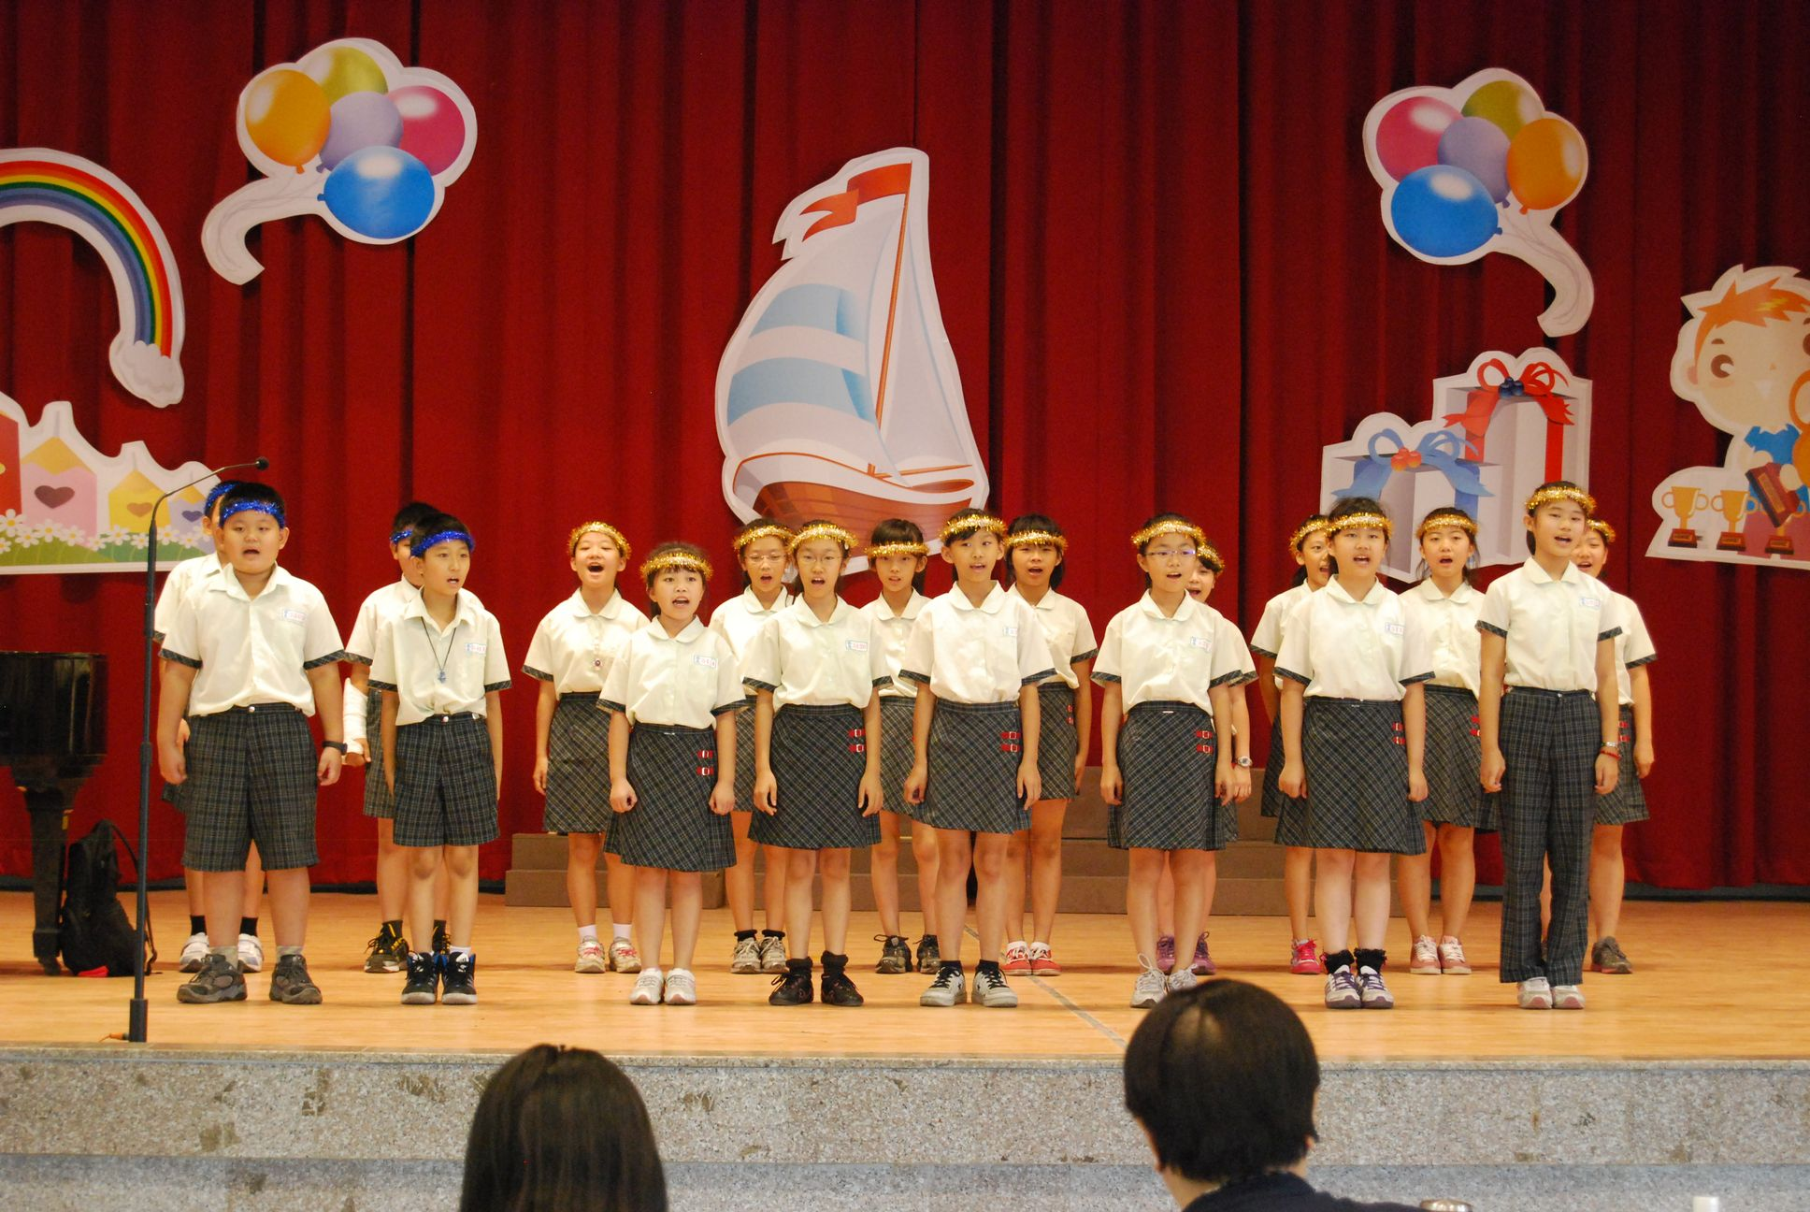

評審群
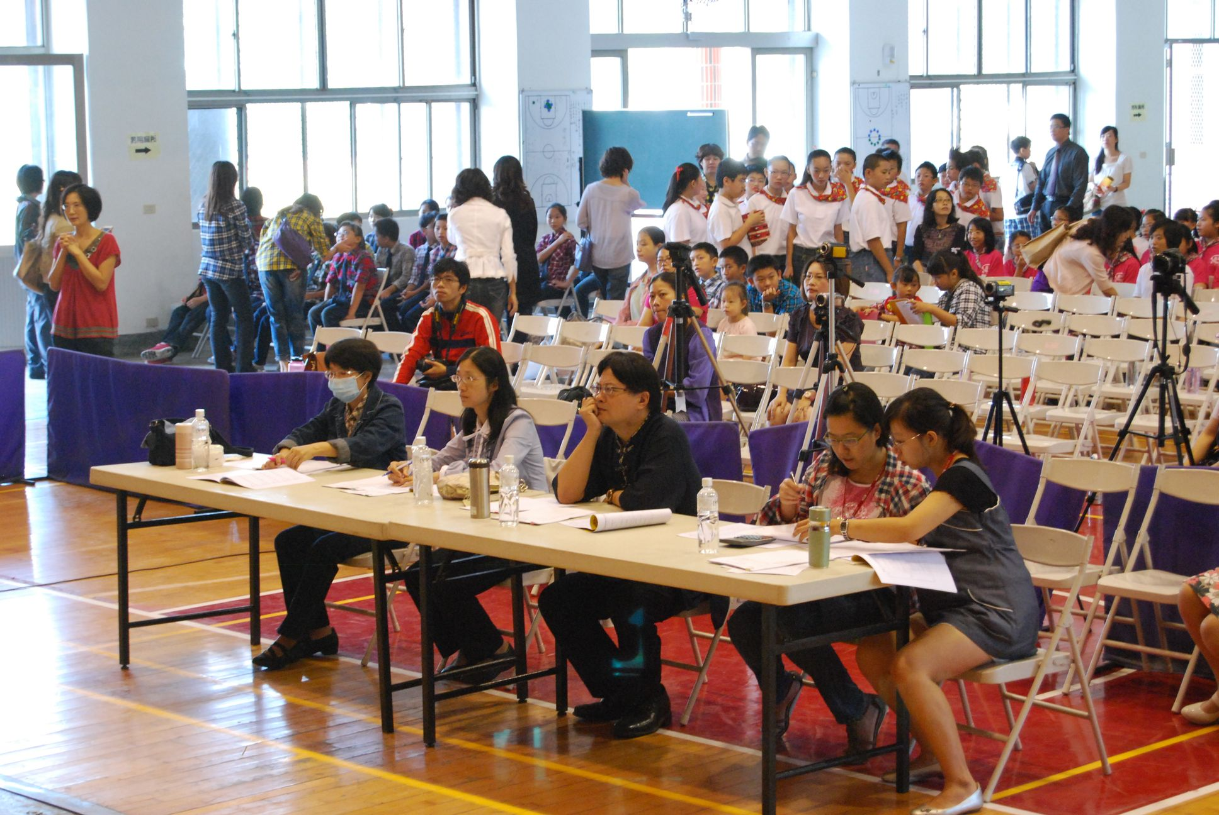

嘉義市101年度提升英語學習成效計畫 英語歌唱比賽- 國中組
玉山國中: Top of the World、Bad Romance
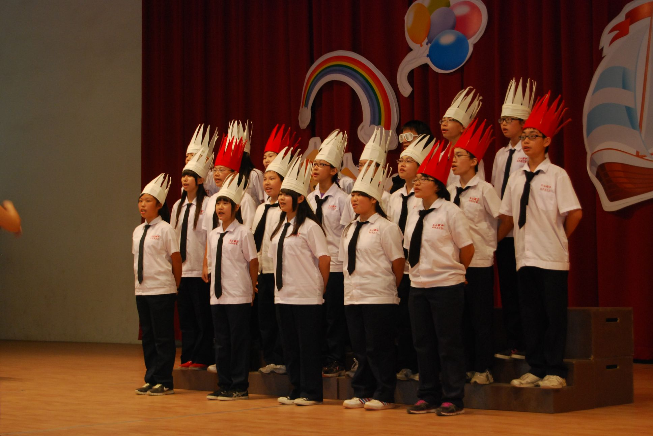

南興國中: Top of the World、Lemon Tree
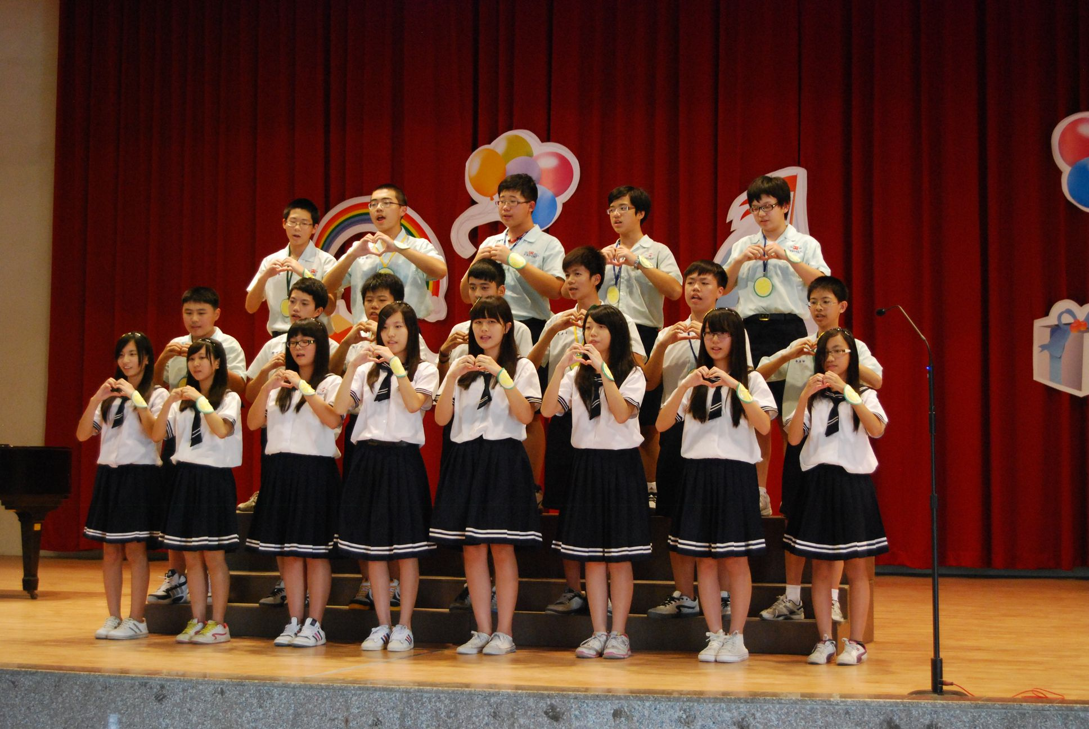

民生國中: Top of the World、Proud of You
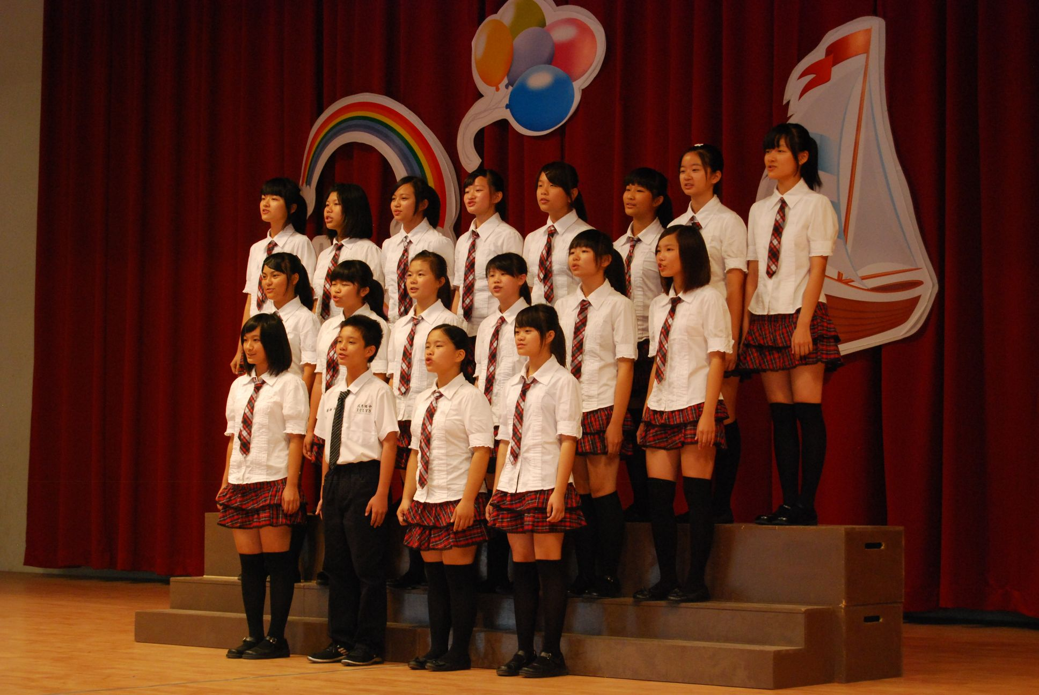

北園國中: Top of the World、A Whole New World

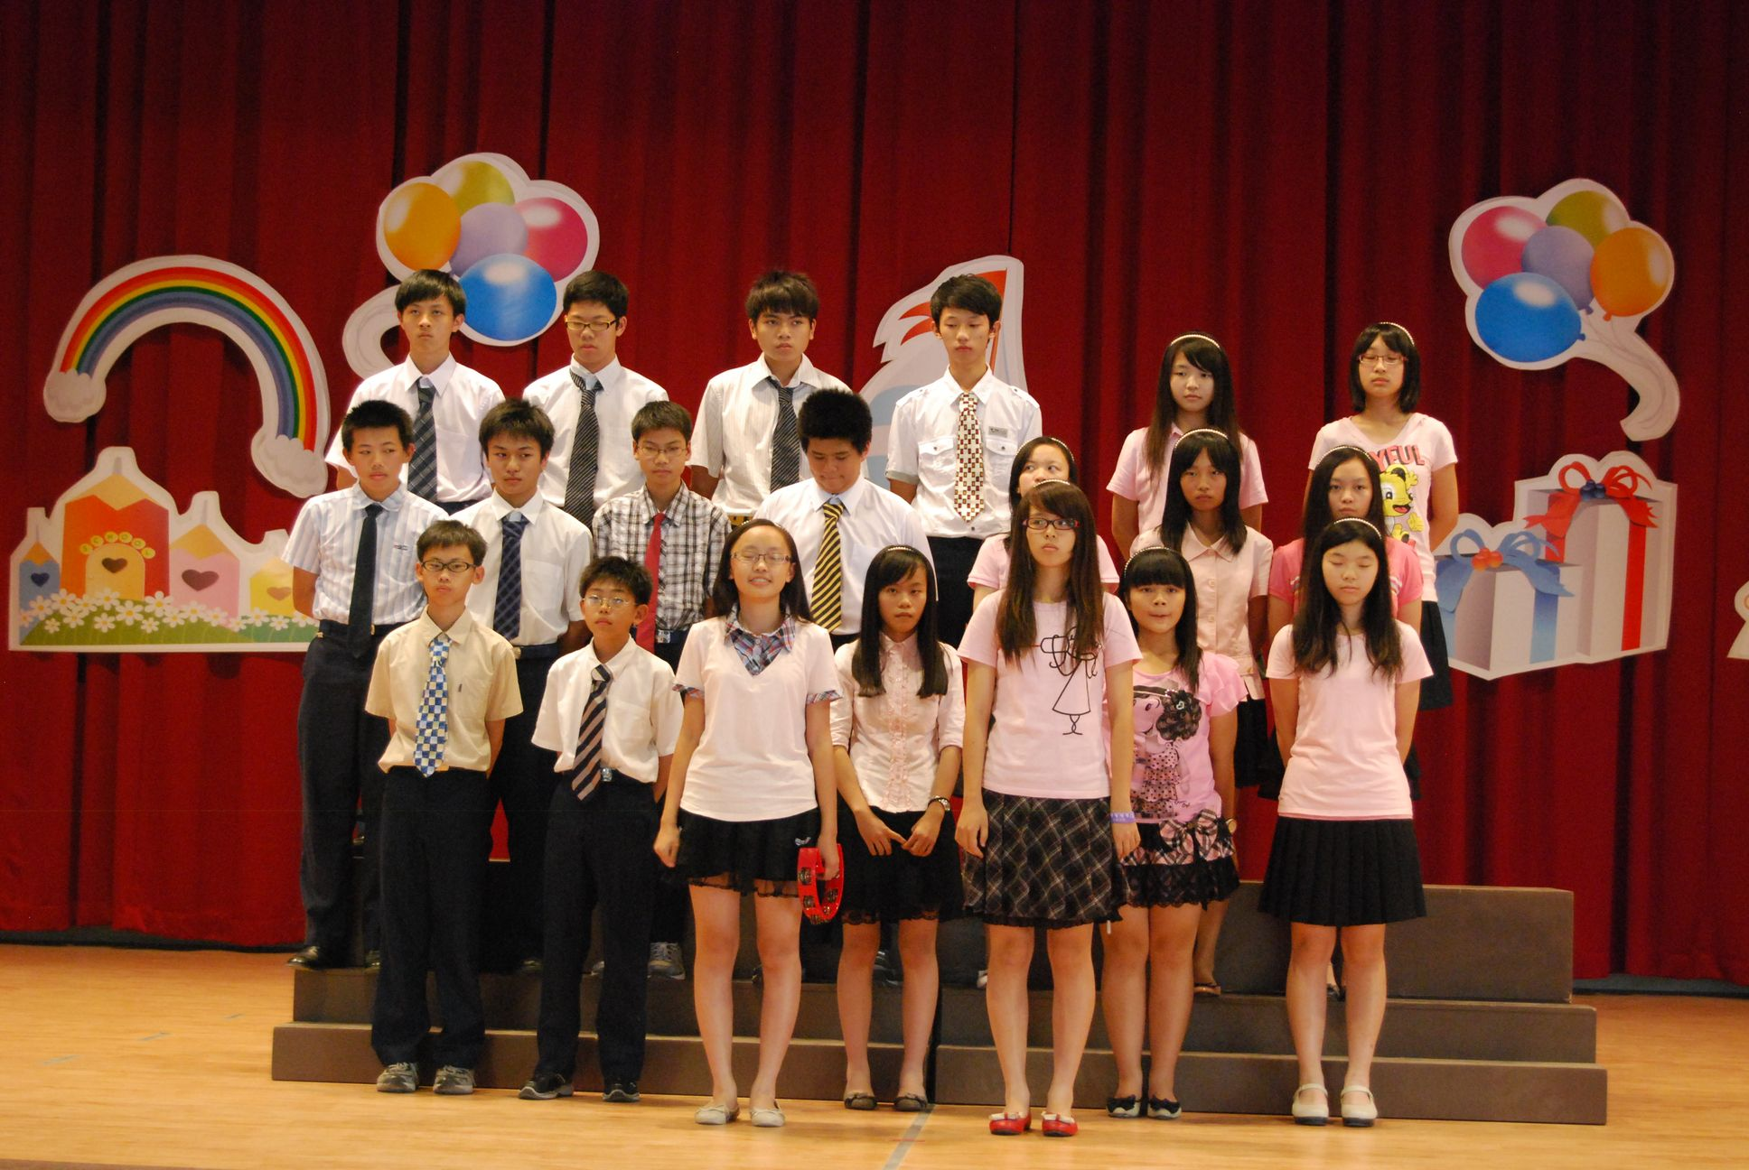

嘉義國中: Top of the World、Heal the World

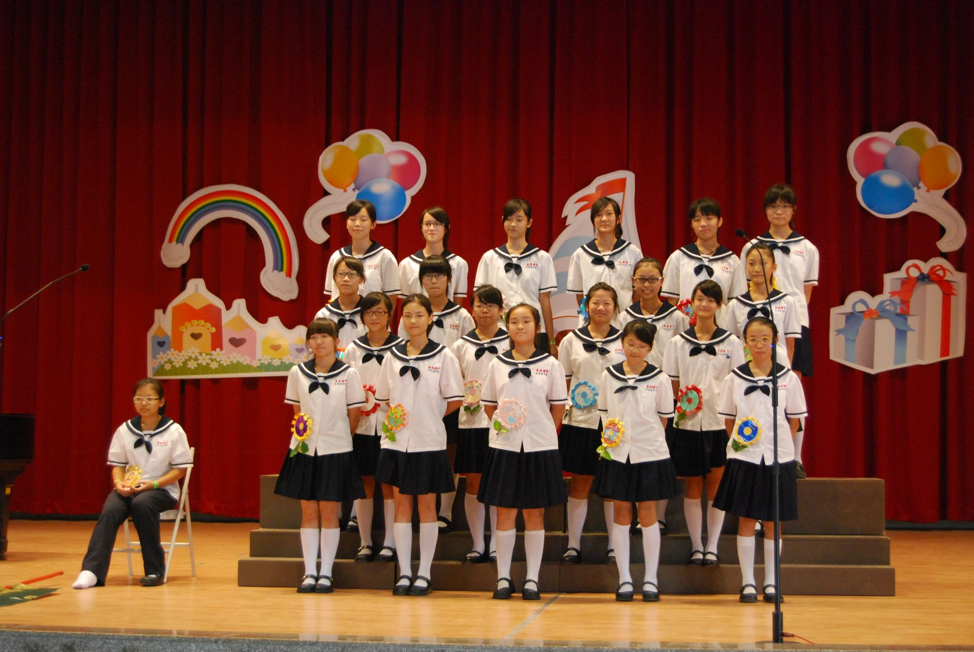

大業國中: Any Dream Will Do、Rhythm of the Rain

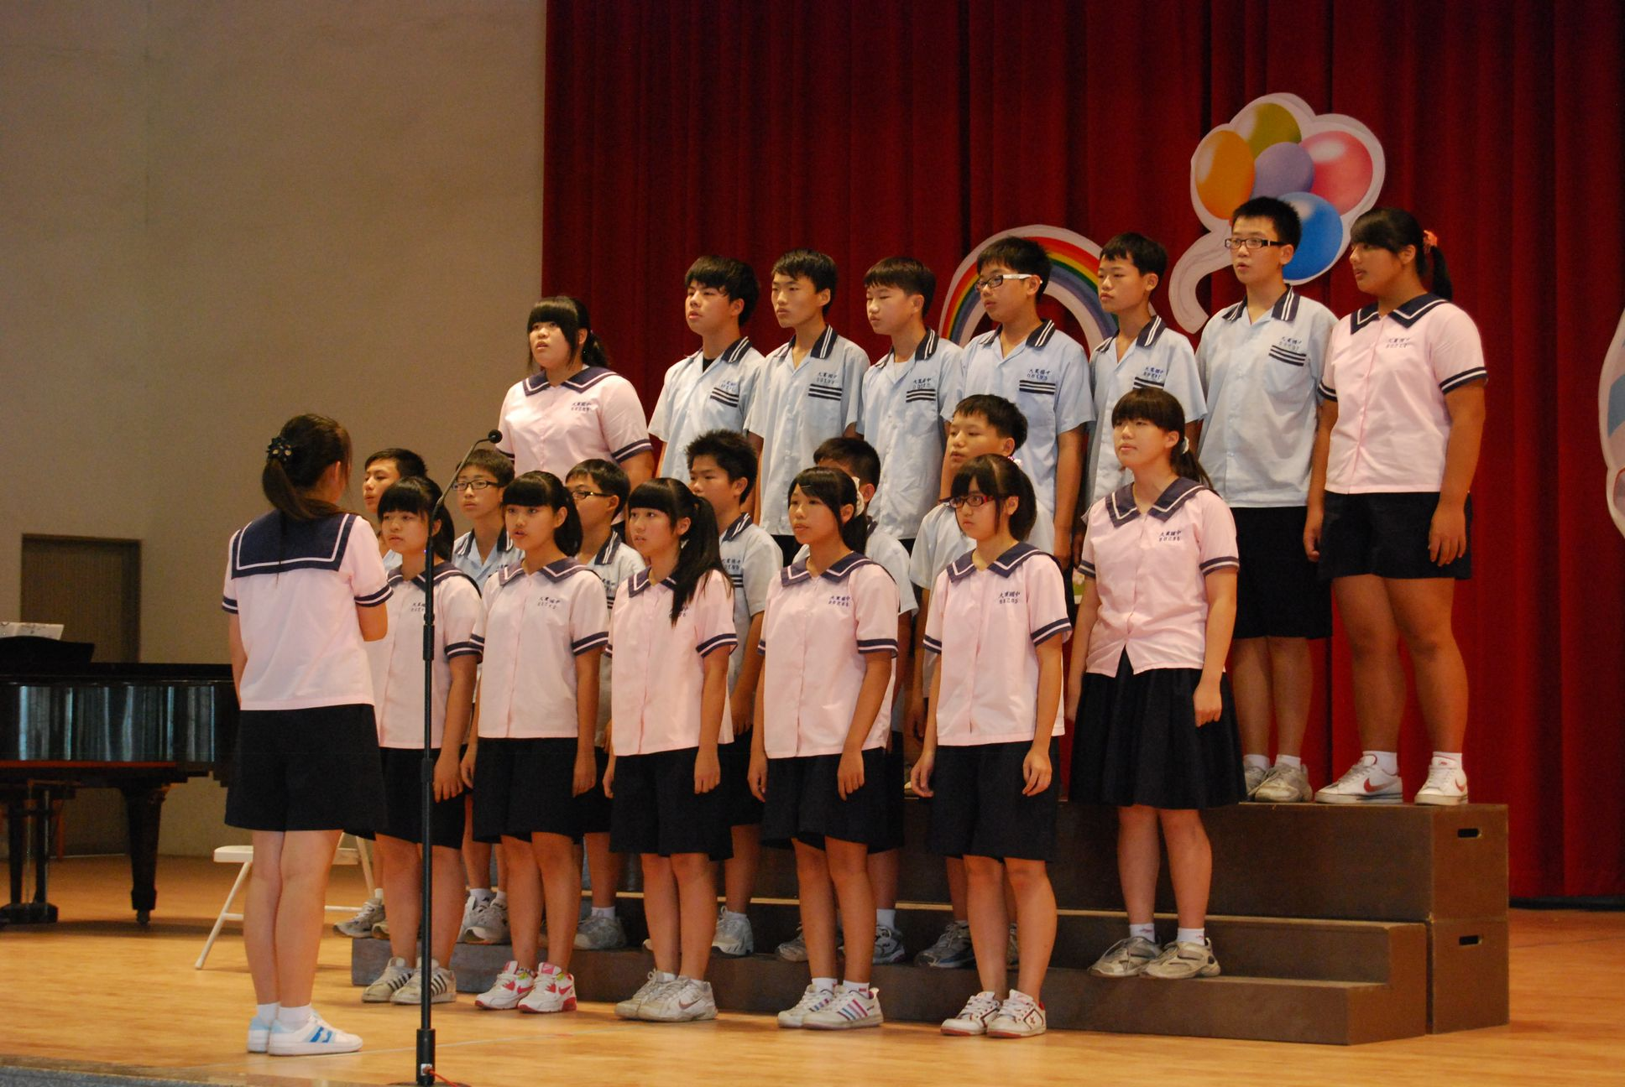

北興國中: Top of the World、Bad Day

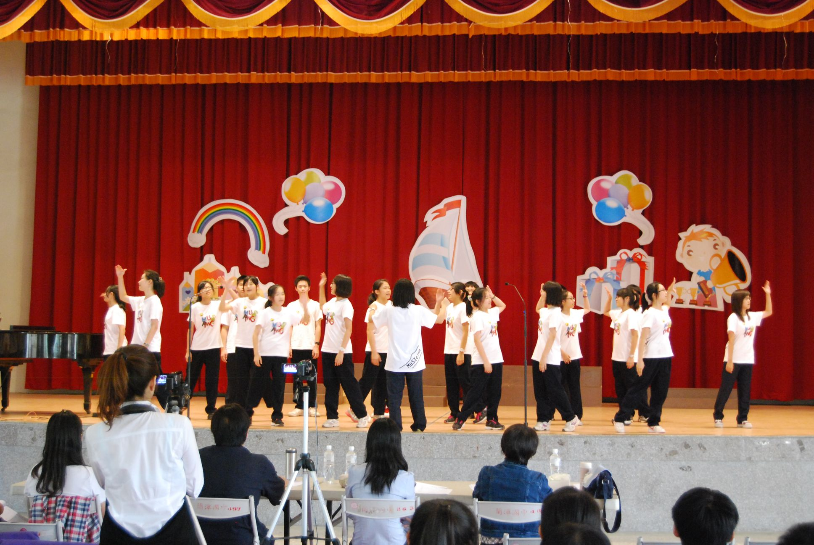

蘭潭國中: Top of the World、I’d Like to Teach the World to Sing

