Step by Step: Get Ready for More!

 Alphabets (write the letters in correct position)
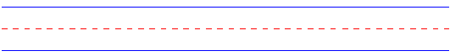

 Alphabets (say the letter names and sounds)
Aa | Bb | Cc | Dd | Ee | Ff | Gg | Hh | Ii | Jj | Kk | Ll | Mm
Nn | Oo | Pp | Qq | Rr | Ss | Tt | Uu | Vv | Ww | Xx | Yy | Zz

Phonics (read and say the CVC words)
cat | yes | dig | pox | jug
mad | vet | Liz | hop | bus
fan | web | tip | not | run

 Target words (read and say the words)
apple | blue | red | green | pencil
banana | book | dog | lion | rabbit
bird | cake | fish | milk | yellow

 Target sentences (read the sentences)
- What’s this? It’s a book.
- What’s that? It’s my pencil.
- What’s your name? My name is _________.
- Is it an apple? Yes, it is.
- Is that a rabbit? No, it’s not.

