比較級：形容詞加er Class:_________ Name:_____________
附件一
※口訣：比較形容詞加er，再加than就有對象。
句型：A比B…
A | is/am/are | 形容詞-er | than | B
I | ________ | _________ | than | __________
____ ________ | ________ | _________ | ____ | ____ ______
____ ________ | ________ | _________ | ____ | ____ ______
____ ________ | ________ | _________ | ____ | ____ ______
我比你高

尺比鉛筆長

老虎比貓壯

這些恐龍比熊大
More Practice
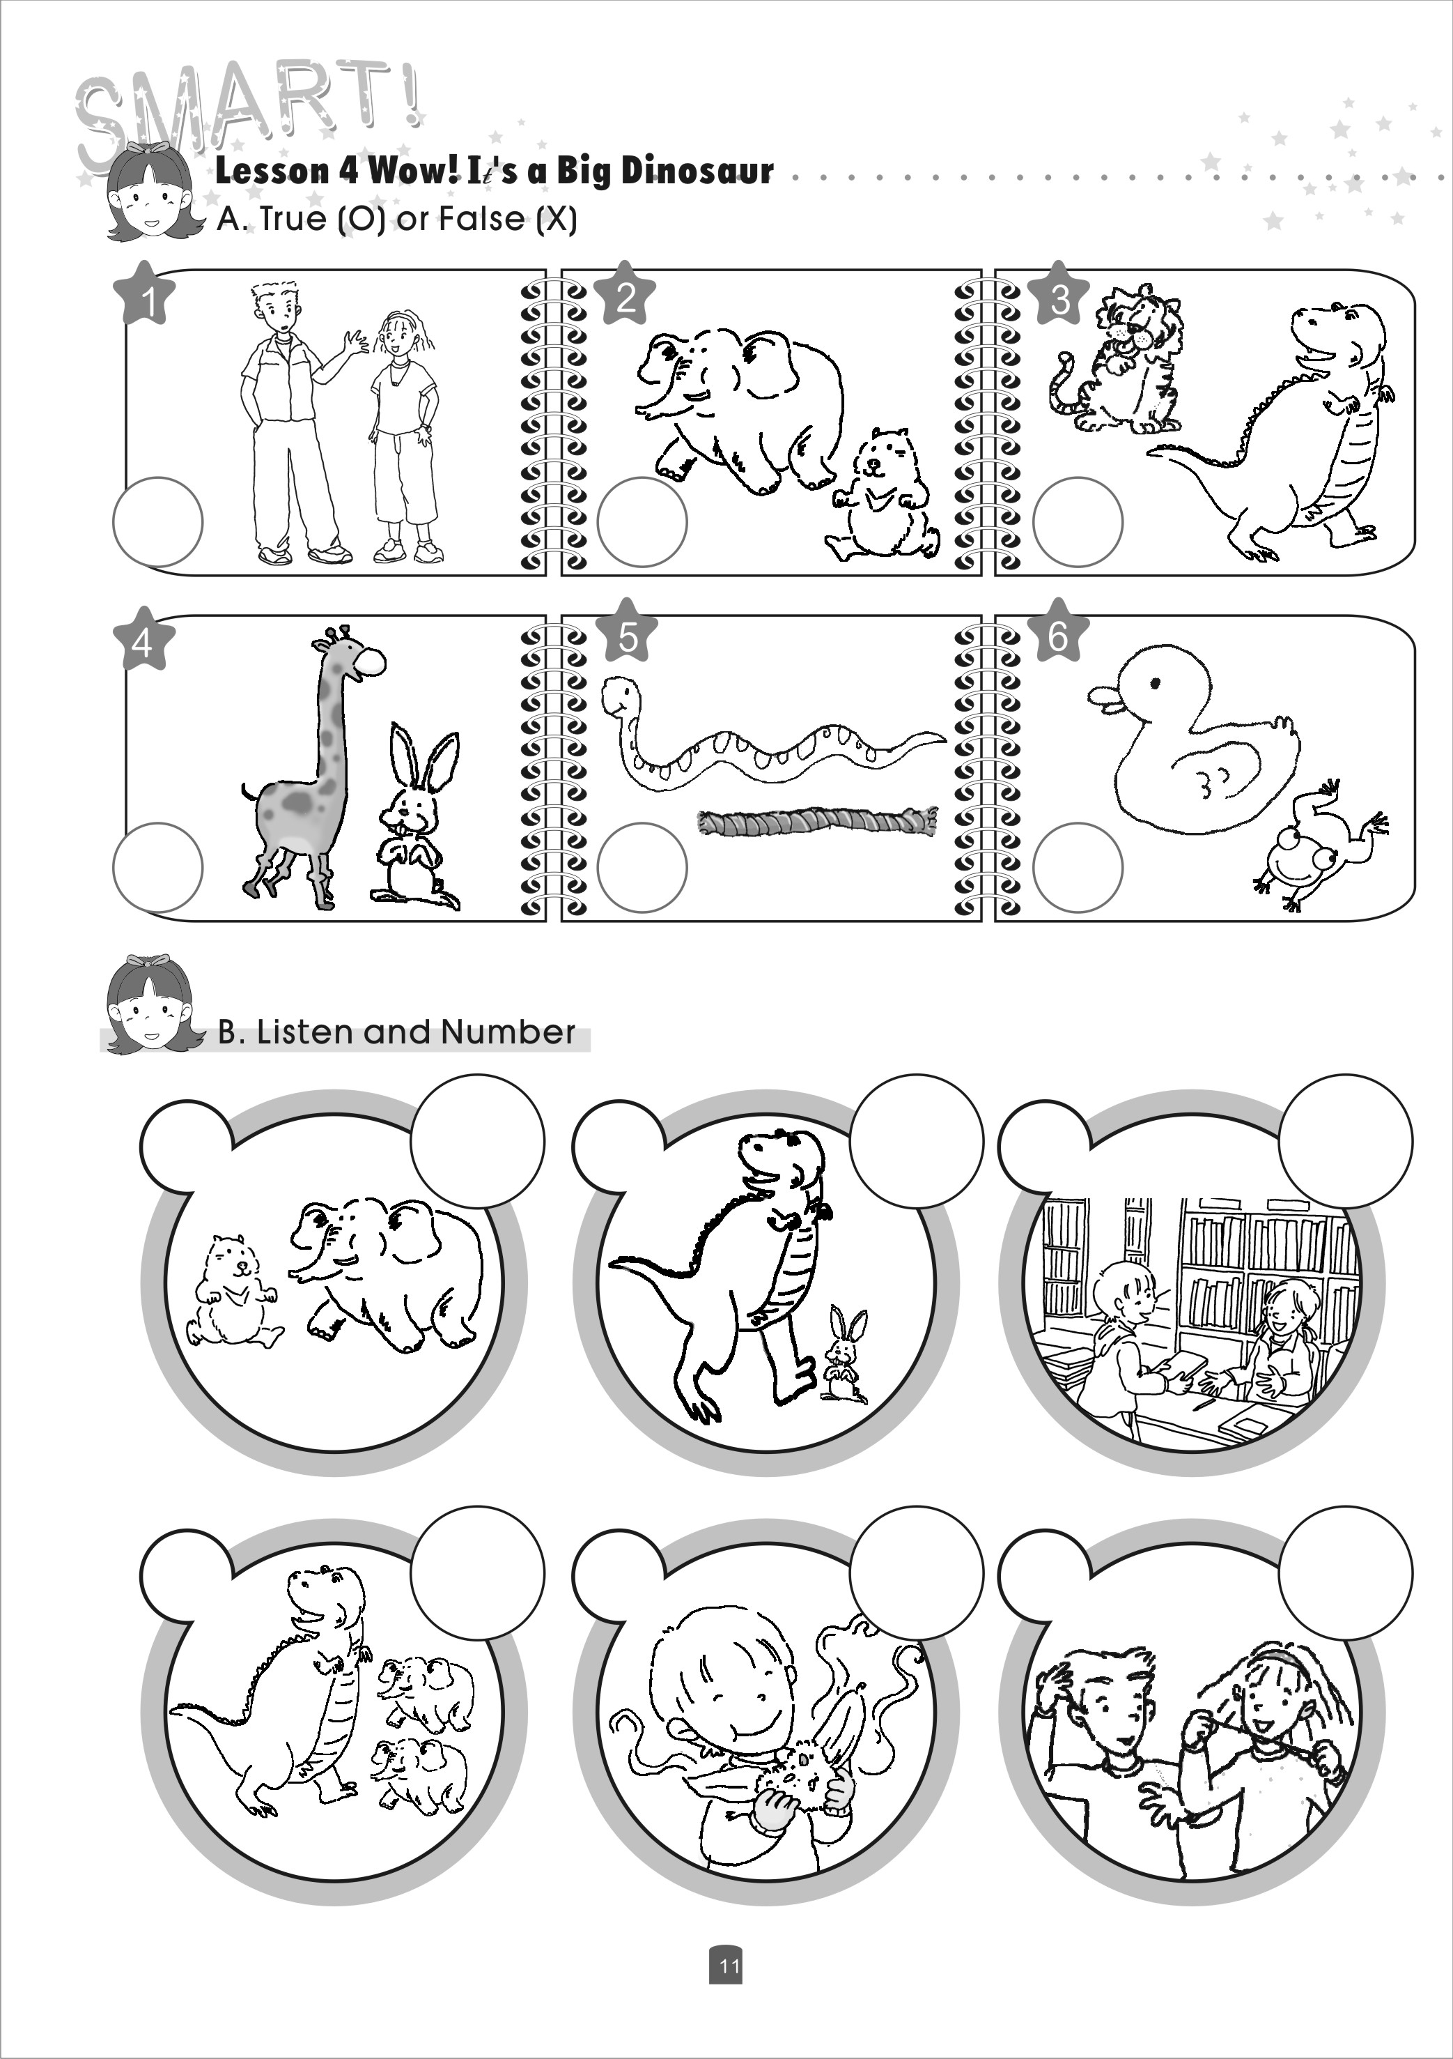

_______________________________________________________________________

_____________________________________________________________________

_________________________________________________________________________

Now you try! Draw a picture and make your own sentence.

_________________________________________________________________

