G703補救教學 教材內容及參考資料

1. 上課主題句型：What’s this/ that? It’s a ruler.
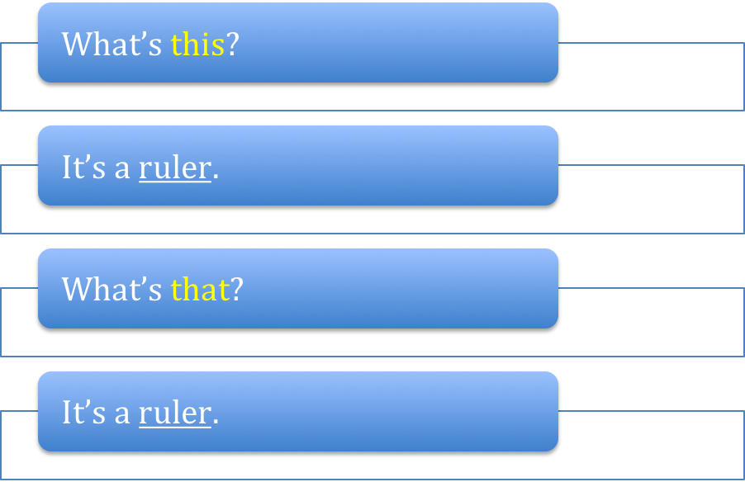
文具物品
文具物品

2. 溝通能力：Ask what this or that is.

3. 單字：
文具：book, eraser, marker, notebook, pencil, ruler, workbook
物品：ball, cellphone, chair, clock, desk, dish, key,
phone (telephone), picture, sofa, table, TV, watch,
window

4. Reference Websites:
- http://www.youtube.com/watch?v=1jqHSmgyZJM&feature=related
- http://www.youtube.com/watch?v=ELAwqdbubXs&feature=related
- http://www.youtube.com/watch?v=9c2dqjJ0Nzw&feature=relmfu
- http://www.youtube.com/watch?v=NqUK-1fn7Ks&feature=relmfu

G703補救教學簡案
Teaching goal: Ss can say their school stationary words
- Warm-up
  - Watch the song on Youtube:
What should you take if you’re going to school: http://www.youtube.com/watch?v=1jqHSmgyZJM&feature=related
  - T uses the words in the clip, and ask Ss to take out their things.

- Presentation
  - Introduce the classroom objects.
Part1: http://www.youtube.com/watch?v=ELAwqdbubXs&feature=related
Part 2: http://www.youtube.com/watch?v=9c2dqjJ0Nzw&feature=relmfu
Part 3: http://www.youtube.com/watch?v=NqUK-1fn7Ks&feature=relmfu
  - Ask the students what objects they have on the desk by using the sentence pattern “ What is this? What is that?

- Activity
  - Ask Ss to write down the English words of the objects in the classroom and paste on them.
  - T uses the sentence pattern: What’s this/ that? to ask Ss to answer.
  - T divides Ss into pairs, and let them practice the sentence pattern.

