新竹市北區西門國小一O二學年度第二學期第二次成績考查五年級英語科試卷

Class_______ No_______ Name_________________ 姓名__________________

分數/人數 分佈 |  | 班級平均 | 家長簽名 | 分數
100 : __________ 人 | 70 ~ 79 : _________ 人 | ___________ 分
90 ~ 99 : _________ 人 | 60 ~ 69 : _________ 人 | ___________ 分
80 ~ 89 : _________ 人 | 59以下: _________ 人 | ___________ 分

Section A: Listen and circle (聽一聽，並圈出所聽到的圖片，每題兩個) 8% 一個圖1分
1. | 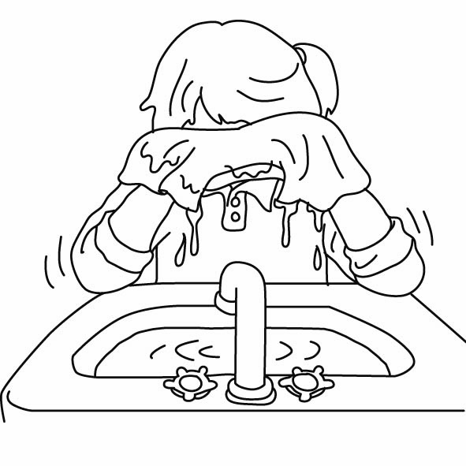 | 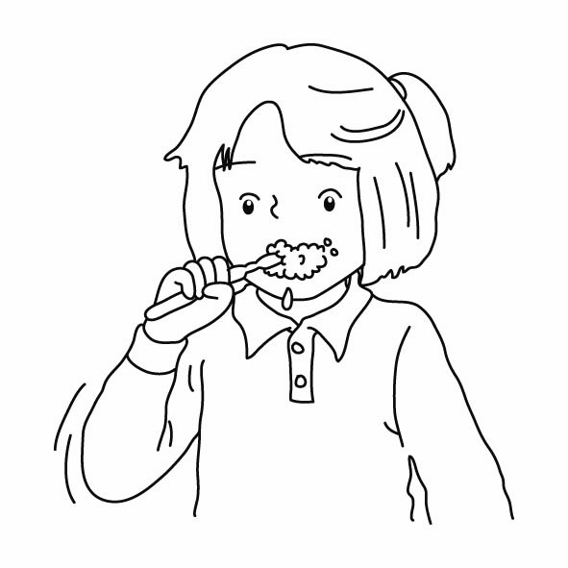 | 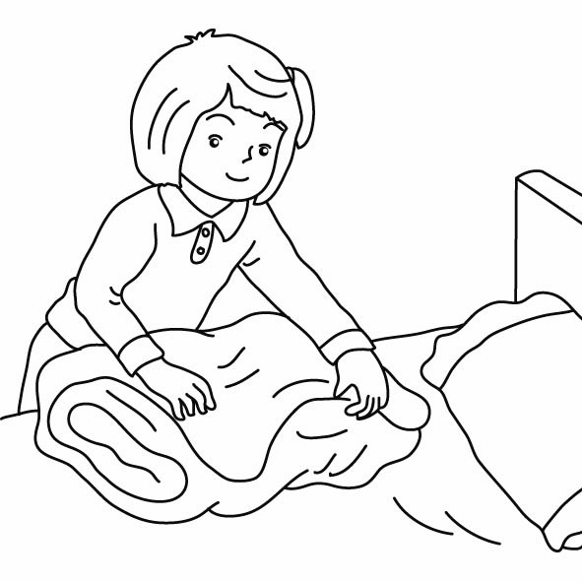 | 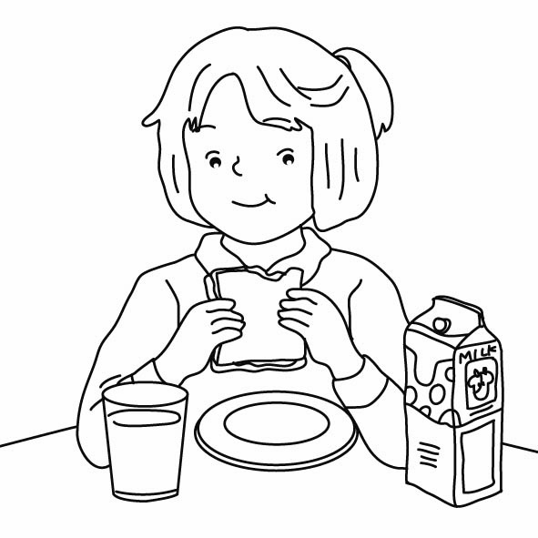
2. | 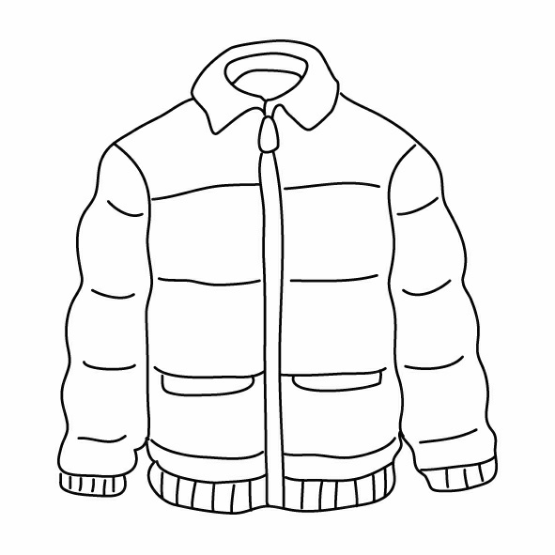 | 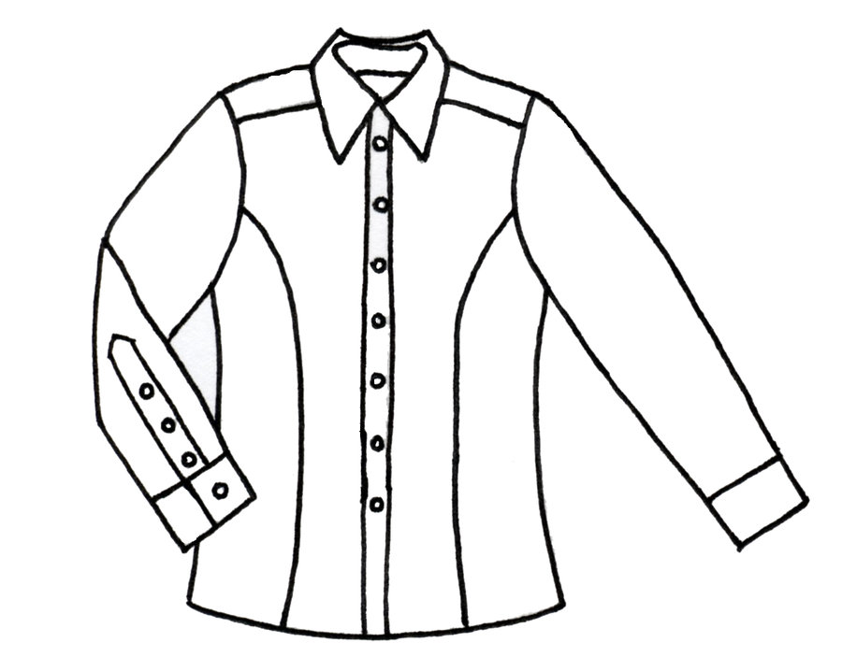 | 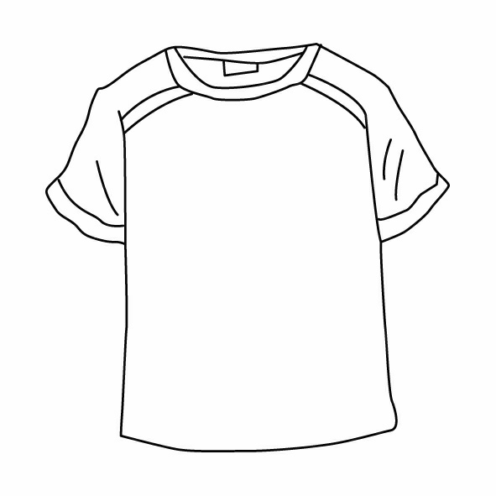 | 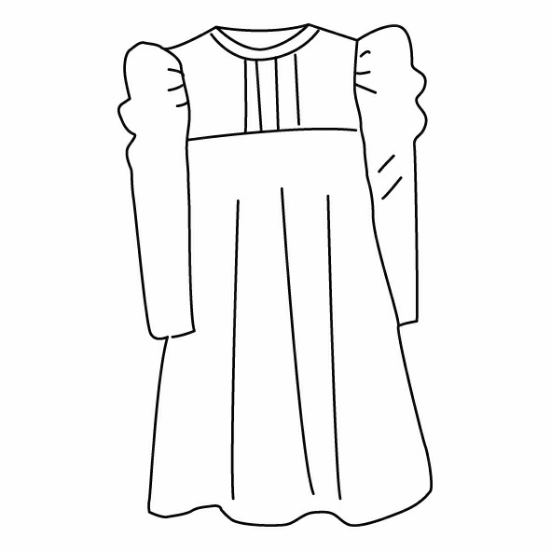
3. | 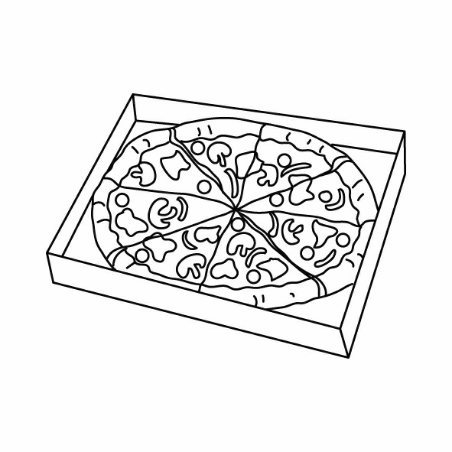 | 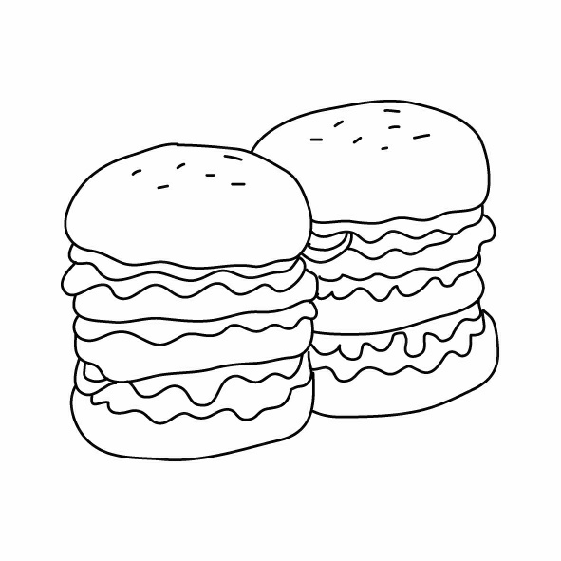 | 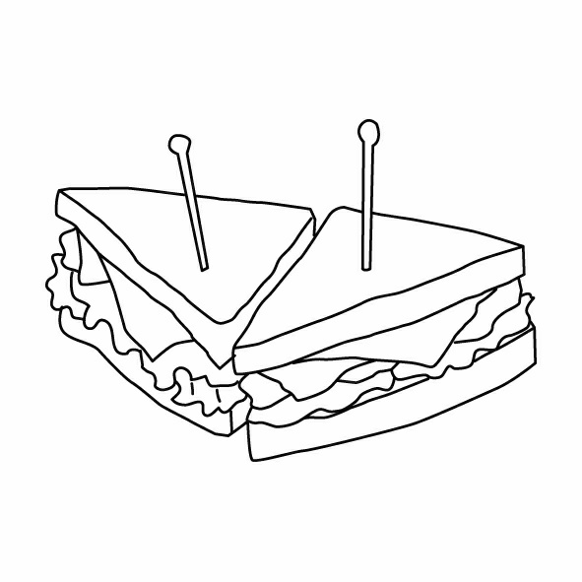 | 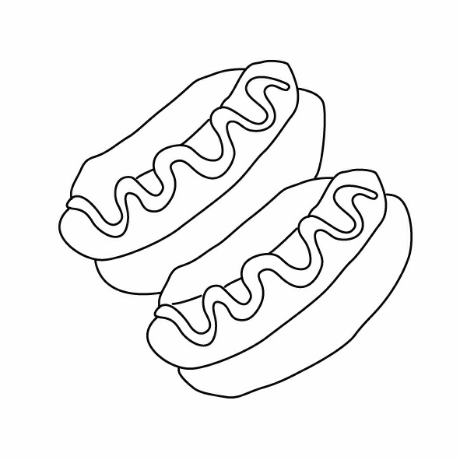
4. | 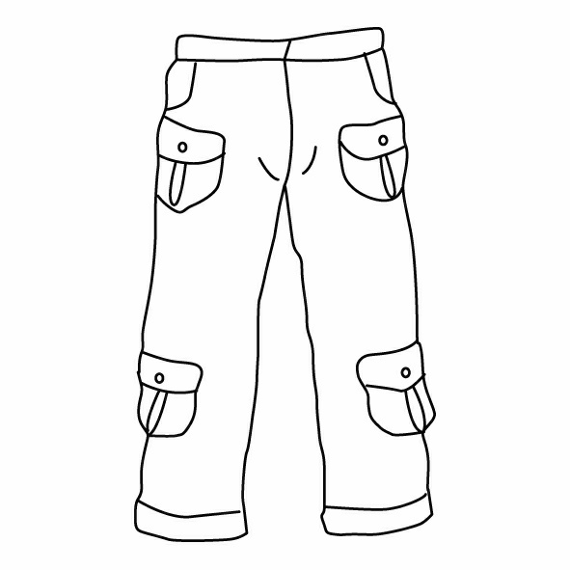 | 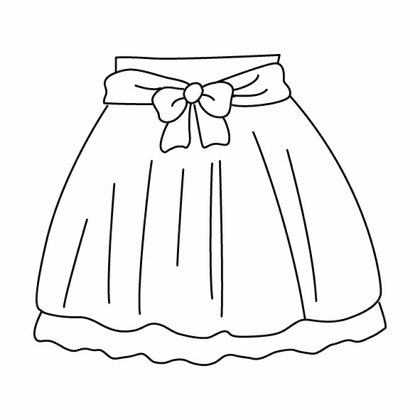 | 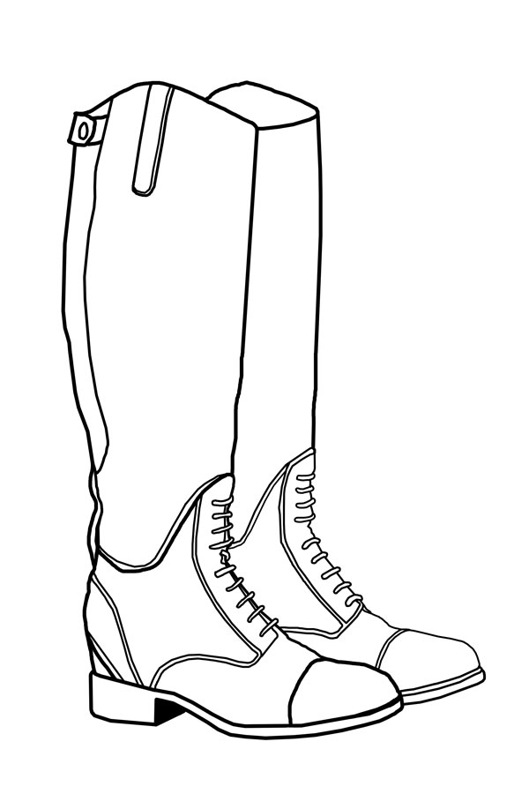 | 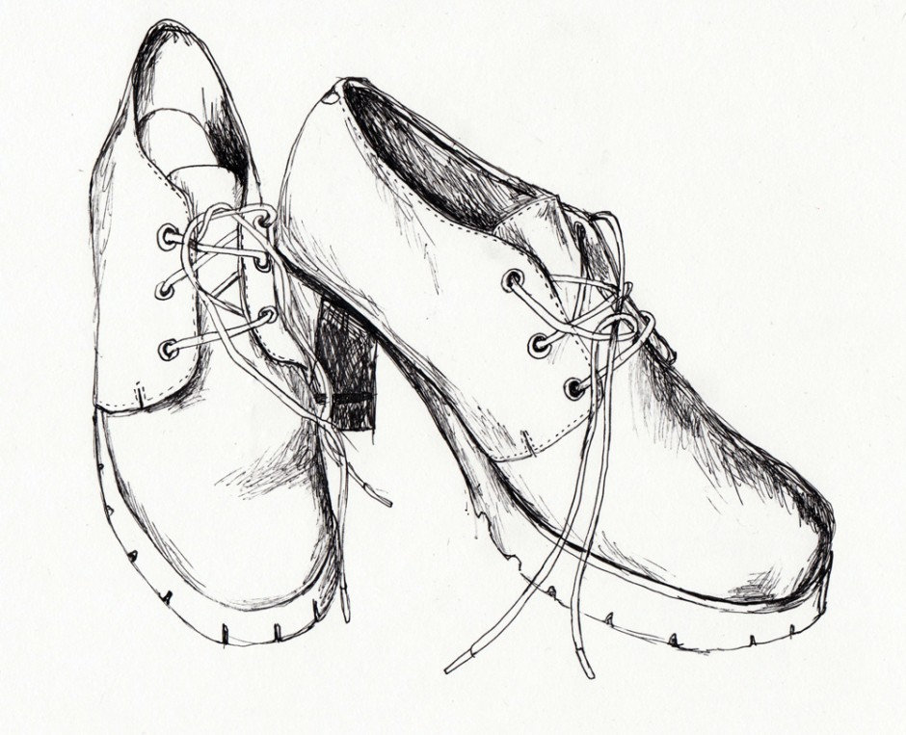

Section B: Listen and fill in (聽一聽，並填入sh / ch / th / ng / nk) 10%
- ______ick | - ______are | - ki______ | - si_______ | - ______is
- ______ose | - thi_______ | - bla_______ | - fi_______ | - too______

Section C: Fill in [θ] or [ð] (聽一聽，在括號中寫出th的讀音符號) 5%
1.[ ] whether | 2.[ ] birthday | 3.[ ] thirty | 4.[ ] there | 5.[ ] bother

Section D: True or False (聽一聽，並判斷對話是否正確；正確請打○，不正確請打X) 10%
1). ( ) | 2). ( ) | 3). ( ) | 4). ( ) | 5). ( )

Section E: Choose the correct answer (根據資料，選出正確的答案) 12%
 I | 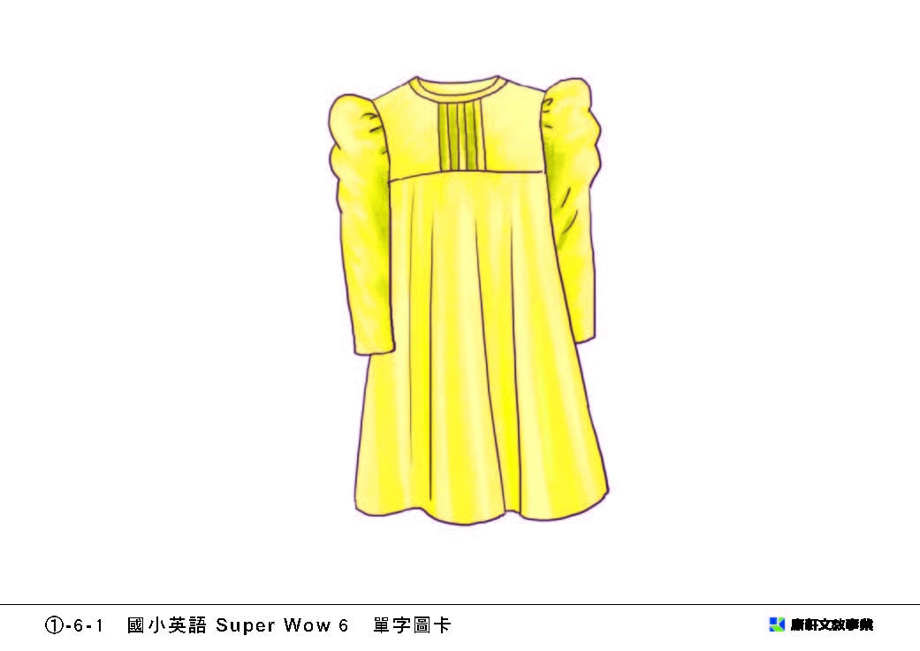NT$3,500 | 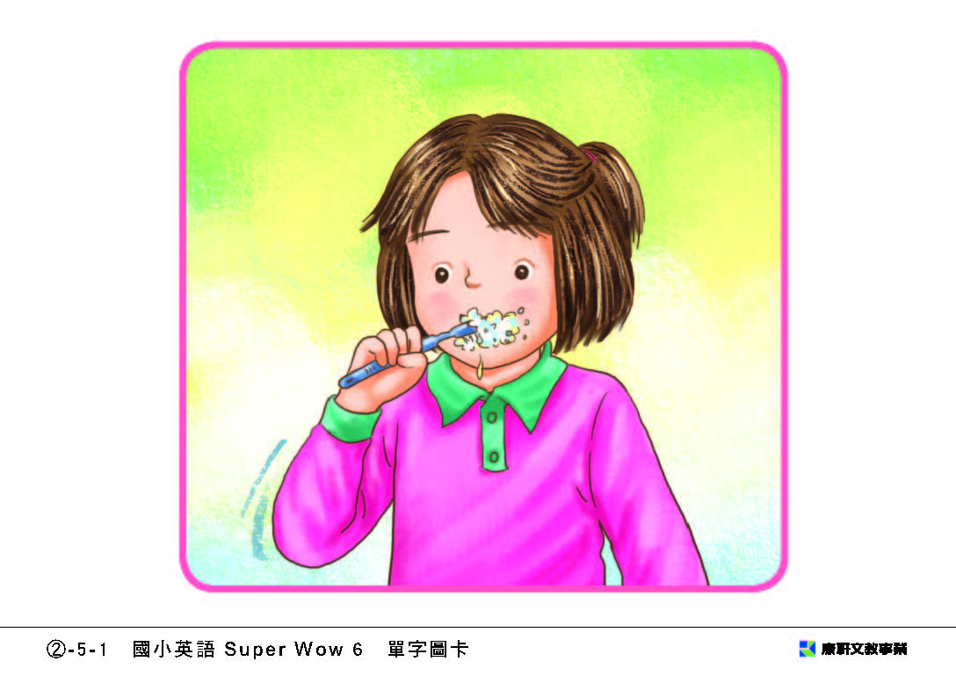 | 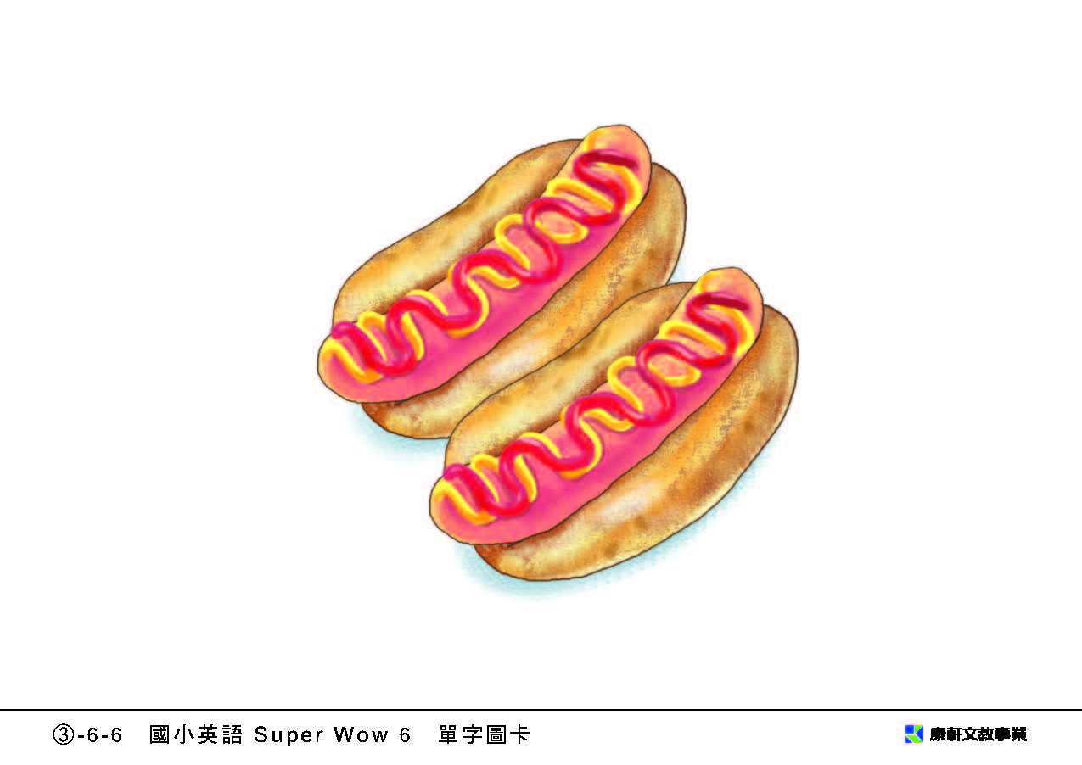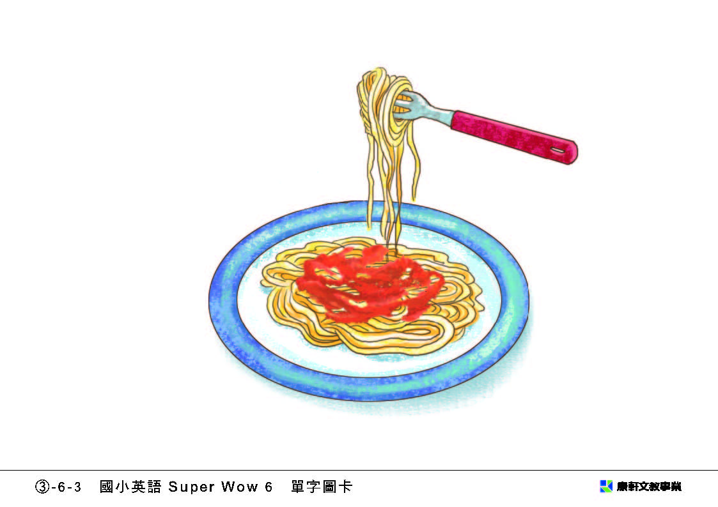
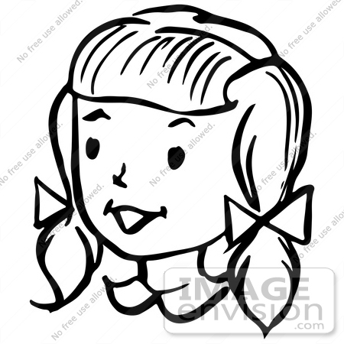 Anna | 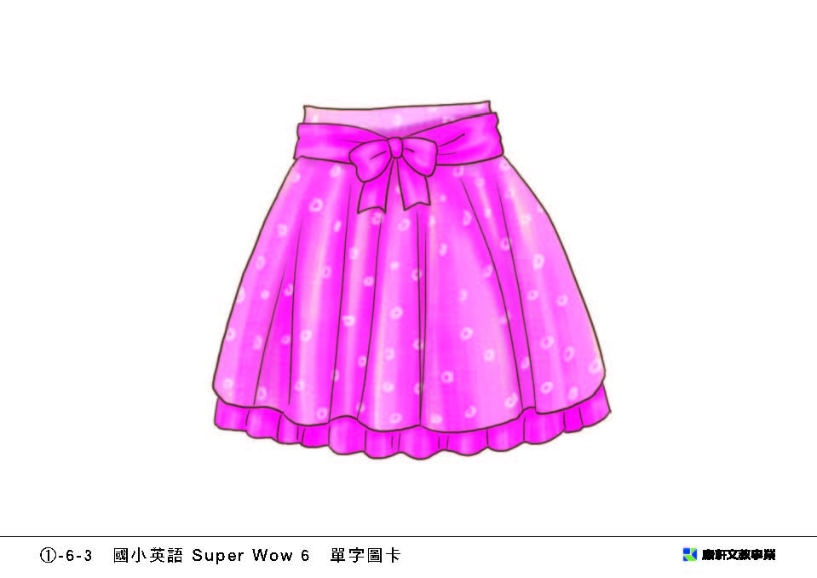NT$1,200 | 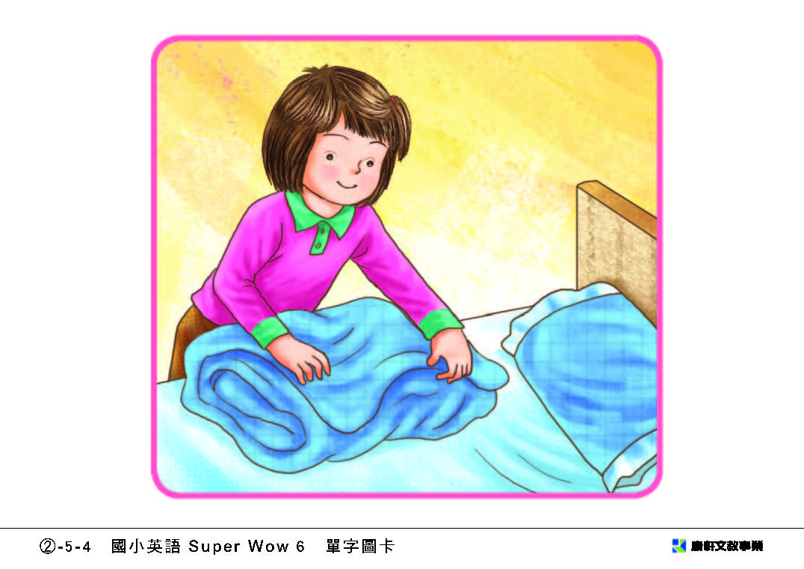 | 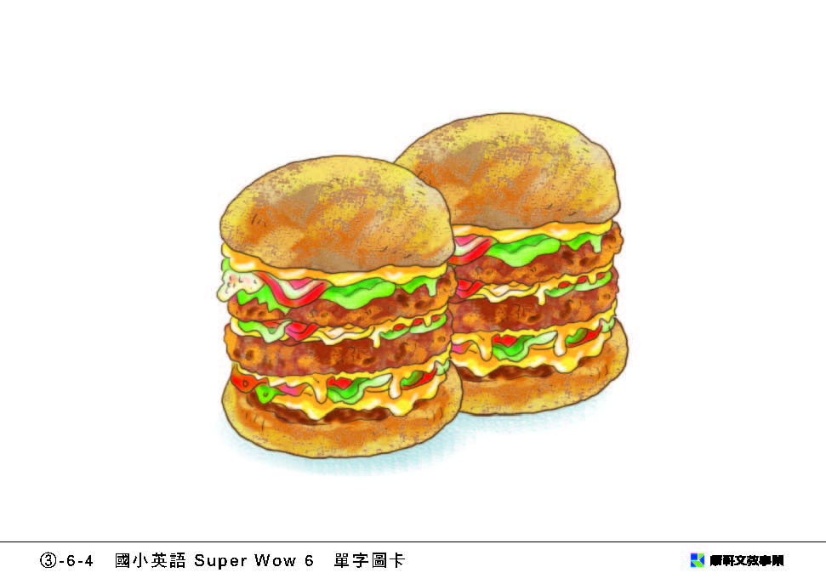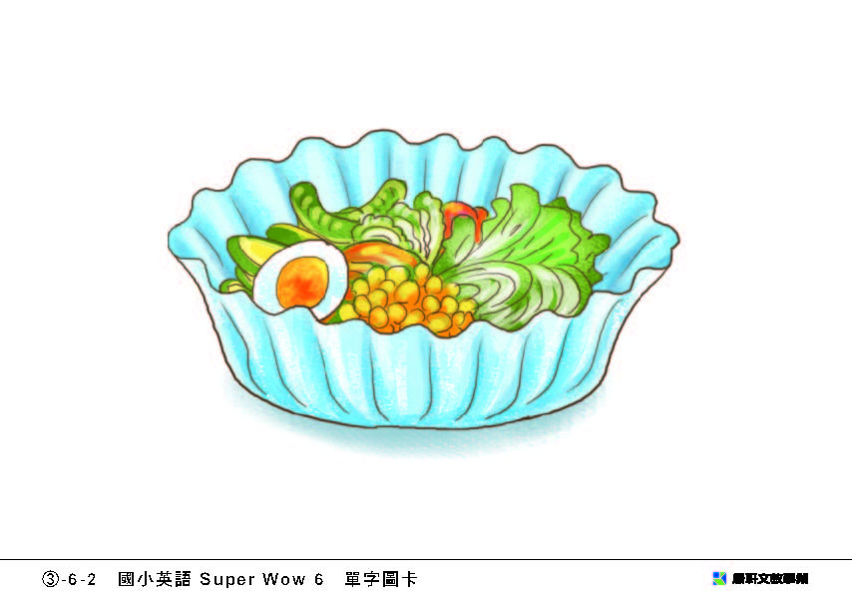
 Mark | 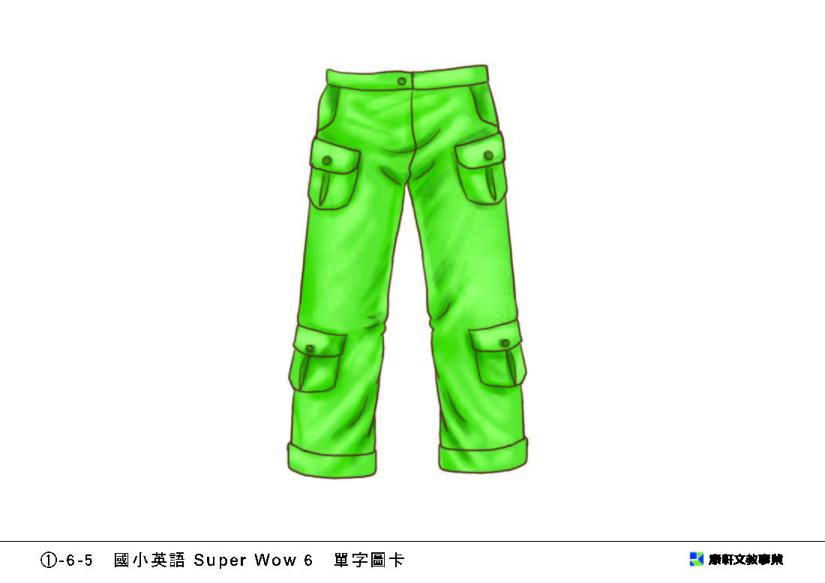NT$2,600 | 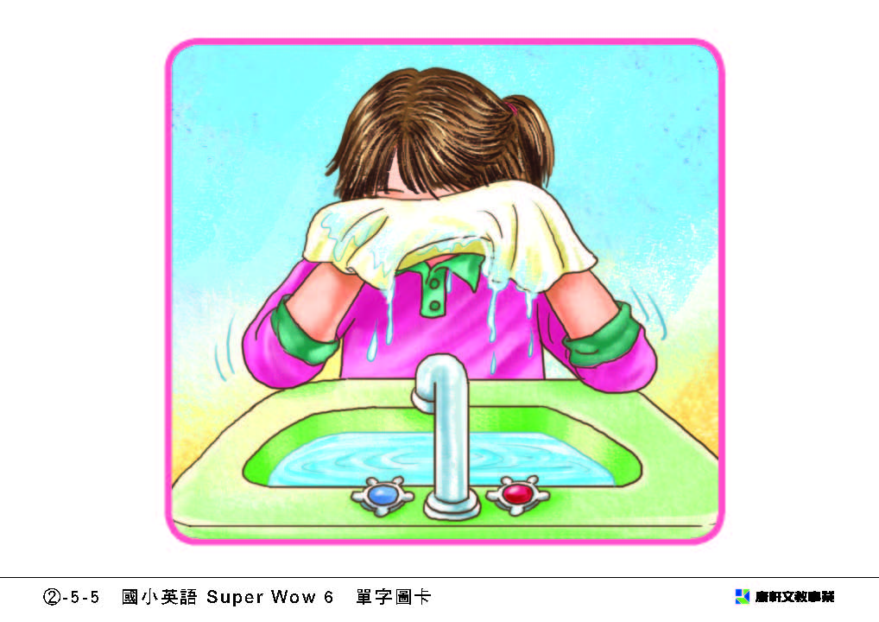 | 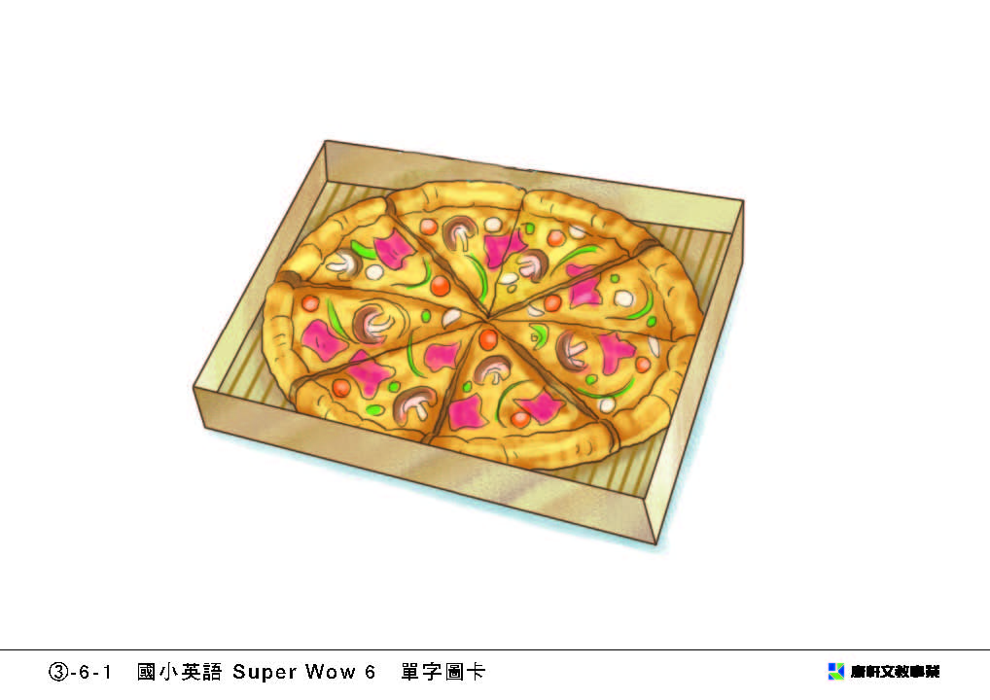

1).( ) | ( a ) He is making his bed.  ( b ) He’s washing his face.  ( c ) He is brushing his teeth. | 2).( ) | ( a ) She likes to eat hot dogs.  ( b ) He likes to eat pizza.  ( c ) They like to eat hamburgers.
3).( ) | ( a ) It’s one thousand dollars.  ( b ) It is one thousand and two hundred.  ( c ) They are twelve hundred dollars. | 4).( ) | ( a ) They are Mark.  ( b ) They are pants.  ( c ) They are Mark’s pants.
5).( ) | ( a ) I like to eat hamburgers.  ( b ) I like to eat hot dogs.  ( c ) I like to eat salad. | 6).( ) | ( a ) She is in the bathroom.  ( b ) She is in the kitchen.  ( c ) She is in the bedroom.

****** The End of Listening Section (聽力部分結束,以下請自行作答!!!) ******
Section F: Sorting (請運用自然發音法則，將字庫中的字依據長母音作歸類) 12%
grow | suit | say | tune | no | tail
bike | sleep | night | tube | group | Steve

Long a [e] | Long e [i] | Long i [aɪ] | Long o [o] | Long u [u] | Long u [ju]

Section G: Add “ing” to the verb (將下列動詞加上ing) 10%
- kid → ___________ | 2. bike → ___________ | 3. jump → ___________ | 4. read → __________ | 5. skate → ___________
6. code → __________ | 7. foam → __________ | 8. sail → _____________ | 9. top → ___________ | 10. swim → __________

Section H: Spelling (請依據圖片拼寫出單字) 6%
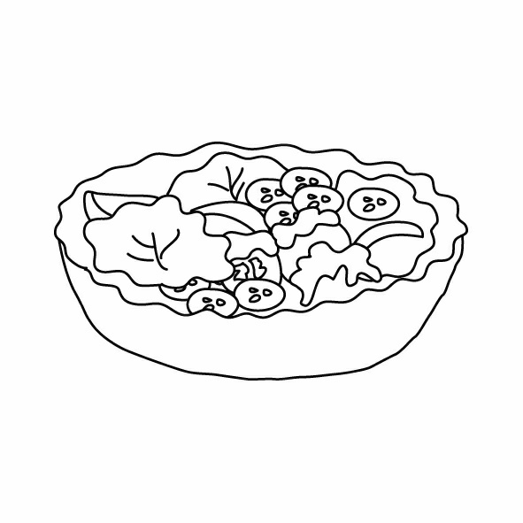 |  |  | 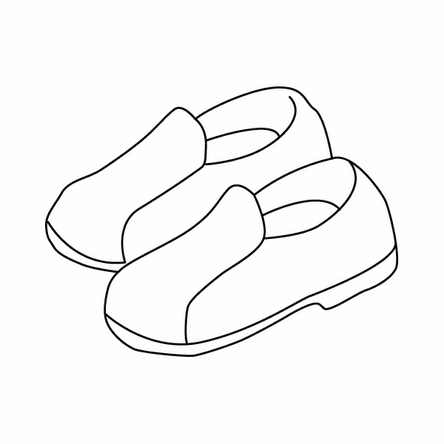 | 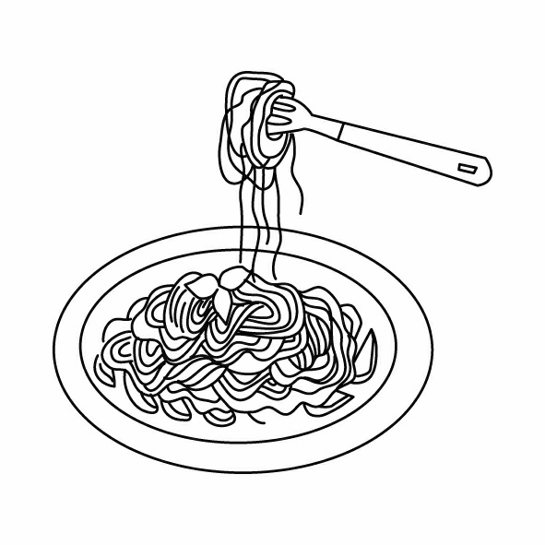 | 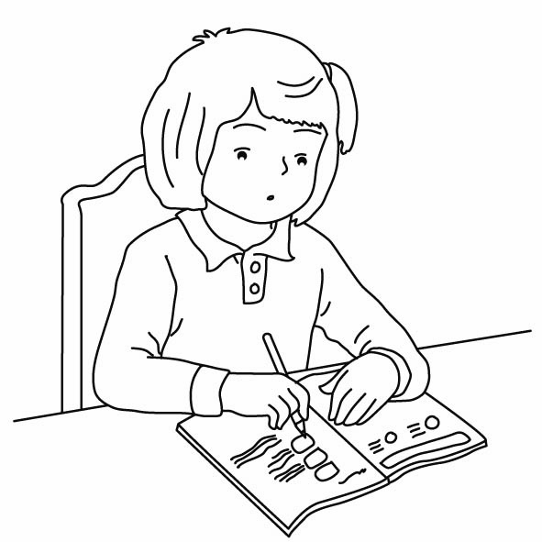
- ___________ | - ________________ | - ___________ | - ___________ | - ____________ | - ________________
(Page 3)
Class_______ No_______ Name_________________ 姓名__________________

Section I: Circle the mistake and correct (圈出錯誤的地方，每題1個； 並於空格中寫出正確答案) 10%
- Andy: What are Jack and Ken do? Jim: They are playing basketball. (__________)
- Mary: What does he like to eat? Annie: He likes to eating hamburgers. (__________)
- Peter: Who’s T-shirt is it? John: It is Amy’s T-shirt. (__________)
- Lisa: What are you doing? Anna and Mark: I are watching TV in the living room. (__________)
- Mrs. Green: How many are the pants? Mrs. White: They are two thousand and six hundred dollars. (_________)

Section J: Fill in the blanks (根據提示在空格中填入適當的答案) 12%
- Q: ___________ are you _____________ ? | A: ___________ am washing ____________ face _________ the bathroom.
- Q: ___________ shoes are ____________? | A: ___________ Andy’s ____________.
- Q: What ____________ Jack like to eat? | A: ___________ ____________ to eat hamburgers and pizza.

Section K: Read the short article and mark O or X (根據短文，判斷是否正確；正確請打○，不正確請打X) 5%
Today is Sunday. It is 3 o’clock in the afternoon. It is a busy(忙碌) day for Lisa, Anna and Mark. They are going to Lily’s birthday party tonight(今晚). They have to get ready(準備) for the party now.  (At Lisa’s house): Lisa is brushing her teeth and washing her face in the bathroom. She is wearing a yellow dress, a white jacket and a pair of white boots for the birthday party. She looks pretty.  (At Anna’s house): Anna is making her bed in the bedroom. She is wearing a pink skirt, a pink shirt and a pair of white shoes for the party tonight. She looks beautiful and cute.  (At Mark’s house): Mark is taking a bath. He is wearing a black and white striped T-shirt, a pair of black pants and a black coat for the party. He looks cool.  It is 6 o’clock in the evening. Lisa, Anna and Mark arrive(抵達) at Lily’s birthday party on time(準時). Lily has prepared(準備) a lot of food and fun games for her friends. Mark likes to eat pizza and sandwiches. Anna likes to eat hot dogs and fries. Lisa likes Chinese food – rice noodles and meat balls.  They all have a great time at the party. They go home at 11:30. They feel happy but tired on their way home(在回家的路上). | - ( ) Lily’s birthday party is on  Sunday night.
- ( ) Mark is washing his face at
3 o’clock on Sunday afternoon.
- ( ) Anna is making her bed in the
bedroom before the party(在派對
之前).
- ( ) Lisa eats pizza, hot dogs and
hamburgers at the party.
- ( ) Lisa, Mark and Anna go home at
11:30 in the morning.

