【國中英語領域召集人研習】

* 教師專業學習社群(PLC)如何運作？

1. 討論_____________________________
2. 分享__________________：邀請領域教師分享教材、教法，透過專業對話，傳承教學經驗。
3. 分享__________________：邀請曾參與研習的領域同仁，於會議中分享研習中所學。
4. 舉辦__________________：由校內教師自發性開放教師，邀請領域同仁入班觀課，互相討論，並精進教學教法。
5. __________________研發：依據校本特色，討論適合學校特色的主題式課程內容。

* 教師專業學習社群(PLC)運作實地演練：研習所學分享

1. 研習名稱：國民中小學英語教師專業發展增能工作坊
2. 研習日期：104年2月5~7 日
3. 主辦單位：教育部國民及學前教育署
4. 協辦單位：英國文化協會
5. 承辦單位：臺南市政府教育局、臺南市安平區新南國民小學
6. 講師簡介：英國文化協會講師 Steven Murray
7. 研習活動說明：講師針對溝通式教學法、差異化教學及英語閱讀等主題進行教案設計分享。
8. 研習課程內容：
   1. 教室英語之運用(Classroom Language in English)
   2. 任務導向教學法(Task-based Learning)
   3. 英語閱讀教學法(Promoting Literacy by Exploiting Readers in the Young Learners)
   4. 寫作教學法(The Forgot Skill-Writing)
   5. 增進聽與說的教學法(Speaking and Listening-Enhancing Skills)
   6. 培養思考能力及國際議題融入教學(Developing Critical Thinking and Discussing Skills)
9. 研習心得：
   1. 靈活運用_____________________________，營造學生的學習動機，提升學習預備度。
   2. 4R – R_______________, R_______________, R_______________, R_____________
   3. 遊戲式活動___________________高，每次使用活動時增加一點點小變化，讓學生不致感到無聊。
   4. Pre-task / Task / Post-task: 課堂間活動的安排很重要，配合學生的_______________________安排活動，能有助提升學習效果。
   5. _______________________很重要：任何遊戲的進行，都必須有良好的秩序與上課習慣，才能發揮最佳的學習效果。

* 活動一：Getting ready

1. 使用遊戲活動於_____________________，主要目的為提高學生預備度。
2. 利用遊戲製造大量_______________________的機會，讓學生能快速熟練單字，引導學生進入主要教學的篇章內容。
3. 善用圖片、聲音、字母方陣、單字投影片、遊戲式教具（如吸盤球）等，增加其_____________________。
4. Word Search:從字母方陣中搜尋目標單字。
5. Word Jumble:打散字母順序後，並辨識單字。
6. Sticky Ball:學生觀看單字投影片，聆聽教師所朗讀的故事，並擲球投中故事中所缺漏的單字。

* 活動二：Information Hunt
  1. 綜合訓練學生「 」、「 」與「 」能力。
  2. 善用教室各個角落，張貼紙張，內容為主要教學篇章的關鍵字詞與句子。
  3. 學生於教室內走動，依據學習單上問題，閱讀紙張上內容，並找出問題的答案。
  4. 完成學習單後，以_________________________方式，A組學生一排，B組學生一排，兩兩學生相對，進行問答練習。

A: Do you know ……?

B: Yes, I know. …… / No, I don’t know. Can you tell me?

* 活動三：Reading Circle
  1. 綜合訓練學生「 」、「 」與「 」的能力。
  2. 學生圍成大圓圈，擺脫以往排排坐的聽講模式。Engage every student to participate.
  3. 每個人輪流朗讀課文。老師視情況跳號，或抽點分心的同學繼續接著唸。
  4. 老師朗讀文章，全體學生聆聽，在句子裡加入錯誤的字，聽出錯誤的學生舉手說Teacher you’re wrong.
* 活動四：Balloon Debate
  1. 以情境式問題，鼓勵學生創意思考：Besides being a teacher, what do you want to be most in the future? List all the group members’answer, and tell your partner why.
  2. The Balloon situation: if you and your group members are on a hot-air balloon ride. Unluckily, the balloon gets into trouble and starts to sink. If it continues to sink you will all die. Only one person can stay in the balloon. So each one of you has to sacrifice. Please discuss the order of scarification: who dies first? And who dies last?

**Word Search投影片**

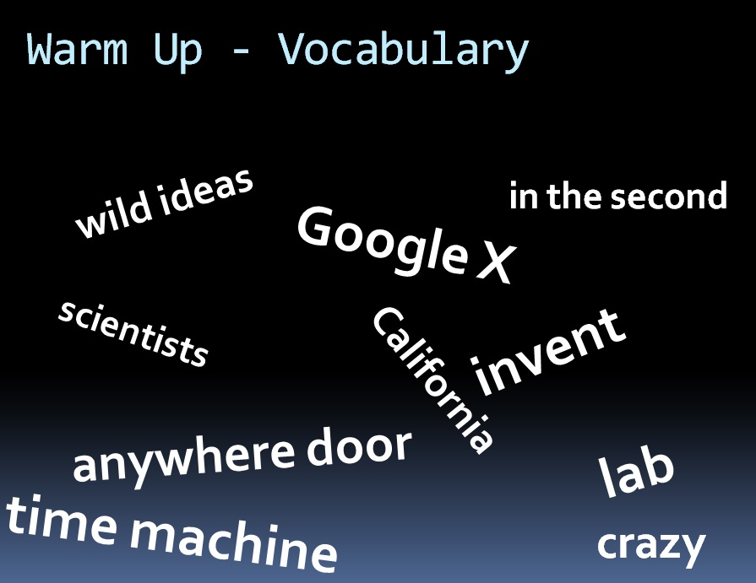

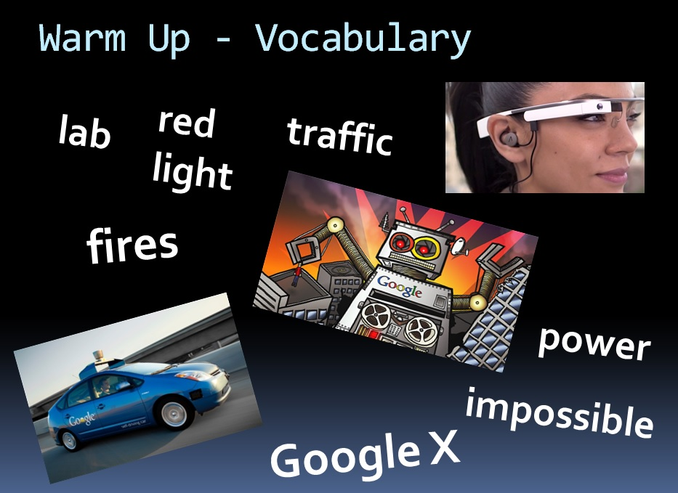

**Information Hunt 張貼紙張**

A Future of Wild Dreams (翰林/第六冊第四課課文)

★ Do you have any ideas that sound crazy? What are they?

Have you ever thought about owning Doraemon, the famous Japanese cartoon robot cat?

With its time machine, you could travel in time. With its anywhere door, you could arrive at school in a second. You may think these ideas sound crazy. However, the scientists at Google X think these ideas may work one day.

Google X is a lab in California. Many scientists there are working on a lot of wild ideas. For example, they are inventing cars which could drive by themselves in traffic and stop at red lights.

They are also working on robots that have super powers to do dangerous work for people, for example, saving people from fires. They are even thinking about building an elevator to go to outer space. In this lab, nothing is impossible.

Do you have any wild ideas? Don’t hold them back. Think like a scientist, and one day you may change the world.

**Information Hunt學習單（A）**

|  |
| --- |
| Questions – (A)  1) What’s the title of this article?  3) What tools do Doraemon have?  kidstalk.jpg5) What can you do with an anywhere door?  7) Where is Google X?  9) What kind of ideas do the scientists in Google X have?  11) What’s so special about the robots invented by Google X scientists?  **好老師們的省思時間：**  問題的設計上，為什麼除了intellectual questions以外，還要設計**opinion question / hypothetical questions**? 英語程度弱的同學若無法表達，該如何協助？  13) Do you have any wild ideas?  garçon-avec-la-question-2979635.jpg14) If you do have a chance, will you want to work in Google X?  f6fdb59d66939a25ca3e86d3009f0ea5.jpg |

**Information Hunt學習單（B）**

|  |
| --- |
| Questions – (B)  2) What is “Doraoemon”?  4) What can you do with Doraemon’s time machine?  kidstalk.jpg  6) What do scientists at Google X think about Doraemon’s tools?  8) What is Google X? f6fdb59d66939a25ca3e86d3009f0ea5.jpg  10) What’s so special about the cars invented by Google X scientist?  12) What’s so special about the elevators invented by Google X scientist?  **好老師們的省思時間：**  問題的設計上，為什麼除了intellectual questions以外，還要設計**opinion question / hypothetical questions**? 英語程度弱的同學若無法表達，該如何協助？  13) Do you have any wild ideas?  garçon-avec-la-question-2979635.jpg  14) If you do have a chance, will you want to work in Google X? |

**Word Jumble 投影片**

#第一張

* kainsg ofr a rawred

**□□□□□□ □□□ □ □□□□□□**

* amek hte rolwd a ttbeer pcela

**□□□□ □□□ □□□□□ □ □□□□□□ □□□□□**

* ragsini mynoe **□□□□□□□ □□□□□**
* hlep oetrhs **□□□□ □□□□□□**
* daneot hte nemoy **□□□□□□ □□□ □□□□□**
* hmseoles poplee **□□□□□□□□ □□□□□□**
* ewllat **□□□□□□**

#第二張

* **pya ti fworrad □□□ □□ □□□□□□**
* **ahotenr tehre popele □□□□□□□ □□□□□ □□□□□□**
* **teka aionct □□□□ □□□□□□**
* **orme nad rmoe peleop**

**□□□□ □□□ □□□□ □□□□□□**

* **tansd pu □□□□□ □□**
* **tnkhi fo na idea □□□□□ □□ □□ □□□□**
* **bceoem a beettr aplce**

**□□□□□□ □ □□□□□□ □□□□□**

**Reading Circle 文章**

Pay It Forward (翰林/第六冊第三課課文)

Bring your PENCILS and BOOKS with you, and sit in a circle!!! ☺

★ How can we make the world a better place?

　　One day, Allen found a wallet on the street. He gave it back to its owner without asking for a reward in return. Instead, he wanted the owner to help others. Then, on his way home, the owner saw a group of students raising money for homeless people. He took out all his money from the wallet and donated it.

　　In the example, Allen practiced the idea of paying love forward. We all hope people who we help can pass on the idea of helping others. After all, in today’s global village, no one can live without the help of others.

　　Another good example of paying love forward is the movie, *Pay It Forward*. In it, a boy is asked to think of an idea that can change the world for the better. He gets an idea–if he helps three people, and each of them helps another three people, then twelve people will be helped. In this way, more and more people will be able to get help. The little boy believes that the world will become a better place if this idea works.

　　After reading the above two examples, we should stand up and take action right away. As we all know, “Actions speak louder than words.” Let’s begin to make the dream of paying love forward come true.