3-1 Vocabulary

Read and Choose

|  |  |  |  |  |
| --- | --- | --- | --- | --- |
| 1. eraser | A. | C:\Users\acer\Desktop\pencil.jpgB. | C:\Users\acer\Desktop\ruler.jpgC. | C:\Users\acer\Desktop\book.gifD. |
| 2. eight | A.  **8** | B.  **7** | C.  **4** | D.  **9** |
| 3. six | C:\Users\acer\Desktop\2.gifA. | C:\Users\acer\Desktop\6.gifB. | C:\Users\acer\Desktop\5.gifC. | C:\Users\acer\Desktop\3.gifD. |
| 4. watermelon | C:\Users\acer\Desktop\banana.jpgA. | C:\Users\acer\Desktop\apple.jpgB. | C:\Users\acer\Desktop\papaya.jpgC. | C:\Users\acer\Desktop\watermelon.gifD. |
| 5. sing | C:\Users\acer\Desktop\jump.gifA. | C:\Users\acer\Desktop\dance.gifB. | C:\Users\acer\Desktop\sing.jpgC. | D.  C:\Users\acer\Desktop\fly.jpg |
| 6. bread | C:\Users\acer\Desktop\egg.jpgA. | B.  C:\Users\acer\Desktop\bread.jpg | C:\Users\acer\Desktop\milk.jpgC. | C:\Users\acer\Desktop\juice.jpgD. |
| 7. library | C:\Users\acer\Desktop\hospital.gifA. | C:\Users\acer\Desktop\library.jpgB. | C:\Users\acer\Desktop\post office.jpgC. | C:\Users\acer\Desktop\bank.jpgD. |
| 8. lunch | C:\Users\acer\Desktop\lunch.jpgA. | B. | C:\Users\acer\Desktop\dinner.pngC. | D. |
| 9. Japan | A.  C:\Users\acer\Desktop\Japan.png | B.  C:\Users\acer\Desktop\India.jpg | C.  C:\Users\acer\Desktop\Singapore.jpg | D.  C:\Users\acer\Desktop\Australia.jpg |
| 10. play basketball | C:\Users\acer\Desktop\listen to music.pngA. | C:\Users\acer\Desktop\play baseball.gifB. | C:\Users\acer\Desktop\ride a bike.jpgC. | D. |

Look and Choose

|  |  |  |  |  |
| --- | --- | --- | --- | --- |
| 1. U2-補15_2 | A. two | B. ten | C. tea | D. the |
| 2. | A. bird | B. dog | C. cat | D. fish |
| 3. | A. red | B. blue | C. green | D. yellow |
| 4. | A.apple | B. banana | C. orange | D. grape |
| 5. | A. father | B. mother | C. sister | D. brother |
| 6. | A. doctor | B. teacher | C. singer | D. cook |
| 7. | A. cloudy | B. rainy | C. windy | D. sunny |
| 8. | A. jacket | B. skirt | C. T-shirt | D. pants |
| 9. | A. angry | B. happy | C. tired | D. sad |
| 10. | A. math | B. Chinese | C. science | D. English |

1. Look, Read and Choose

|  |  |
| --- | --- |
| 1.( ) | 1. It’s sunny. They are having fun in the park. 2. It’s rainy. They are reading in the library. 3. It’s sunny. They are going to school.   (D) It’s rainy. They are sleeping at home. |
| 2.( ) | A:\_\_\_\_\_\_\_\_\_\_\_\_\_\_\_\_\_ ?  B: They are bananas.  (A)What are these?  (B)Do you like bananas?  (C)What are those?  (D)Do you like watermelons? |
| 3.( ) | P24-1  A: How do you go to school?  B: \_\_\_\_\_\_\_\_\_\_\_\_\_\_\_\_\_\_\_\_  (A) I go to school on foot.  (B) I go to school by car.  (C) I go to school by bike.  (D) I go to school by MRT. |
| 4.( ) | A: What time does Amy \_\_\_\_\_\_\_\_\_\_\_\_\_?  B: She \_\_\_\_\_\_\_\_\_\_\_\_\_\_\_\_\_\_\_ at 12:00.  (A) go gome; goes home  (B) get up; gets up  (C) study English; studies English  (D) have lunch; has lunch |
| 5.( ) | 680623  (A)　Thank you, Tom!  (B)　Happy birthday, Tom!  (C)　How are you, Tom?  (D)How old are you, Tom? |
| 6.( ) | (A)I want some cola and an apple pie.  (B)I want some juice and two apple pies.  (C)I want some tea and three hot dogs.  (D)I want some juice and a hot dog. |
| 7.( ) | (A)He is from Japan.  (B)He is from the UK.  (C)He is from the USA.  (D)He is from Taiwan |

4-1

**一、 Look & Write 看到的大寫字母，請轉換成小寫。**

A. H →\_\_ 2. E →\_\_ 3. B →\_\_ 4. I →\_\_ 5. R →\_\_

二**、 Look & Write 看到的大寫字母，請轉換成小寫。**

**B.**

1. h

2. e

3. b

4. i

5. r

**三、Please transfor the letter from capital or small letter, and then read the word.**

**請把字母大小寫做轉換並讀出單字來。(30%)**

1.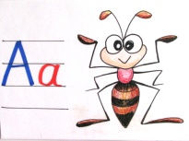 ANT 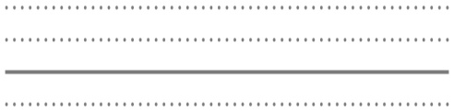

2.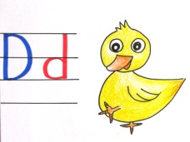 duck 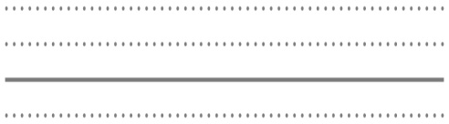

3.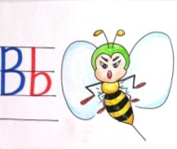 BEE 

4.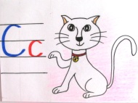 cat 

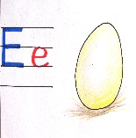5. EGG 

**四、Read and Write 依照字母順序，寫出大寫或小寫字母。(30%)**

1.

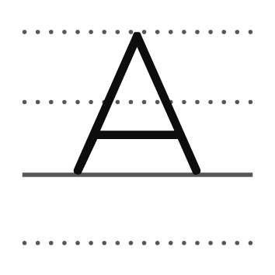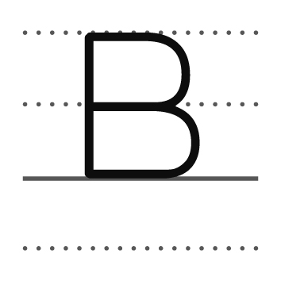 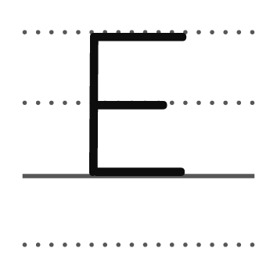

2.

 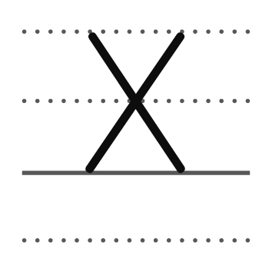 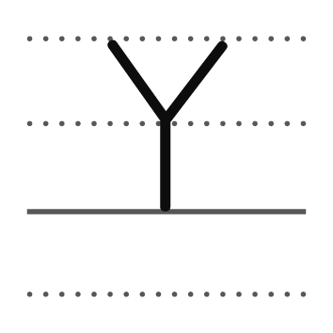 

3.

4. 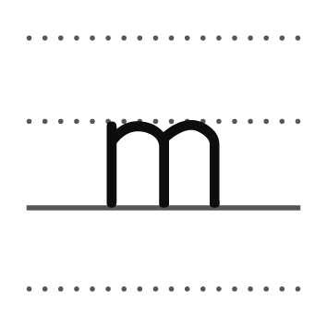  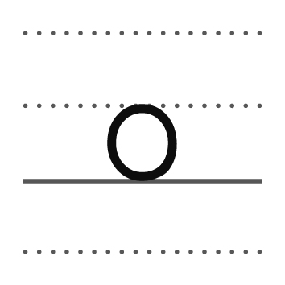 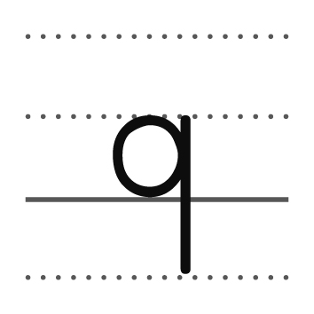

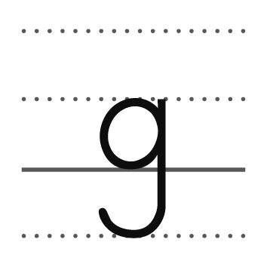 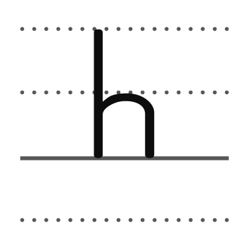  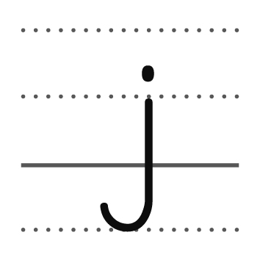 

5.

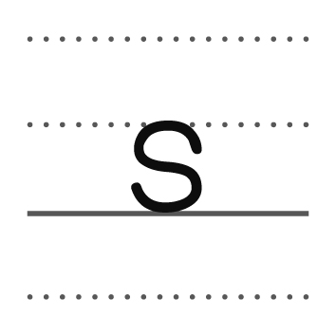  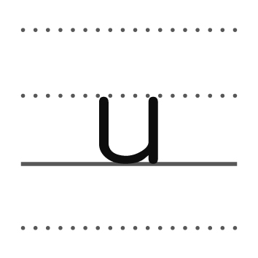  

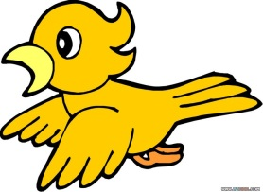 → b d

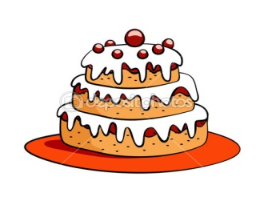 c k

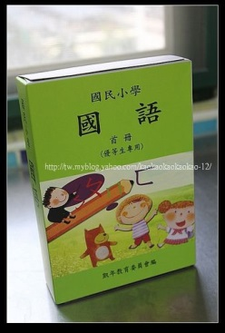 in s

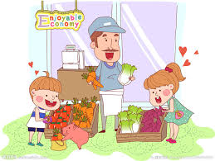 → s p m k t

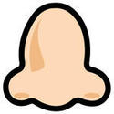 →

 →

拼寫重要單字

**It’s a \_\_\_\_\_\_\_\_\_\_\_.**  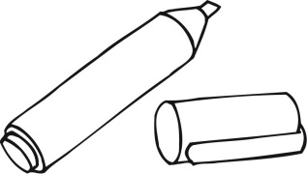

**Is this a \_\_\_\_\_\_\_\_\_\_\_?**  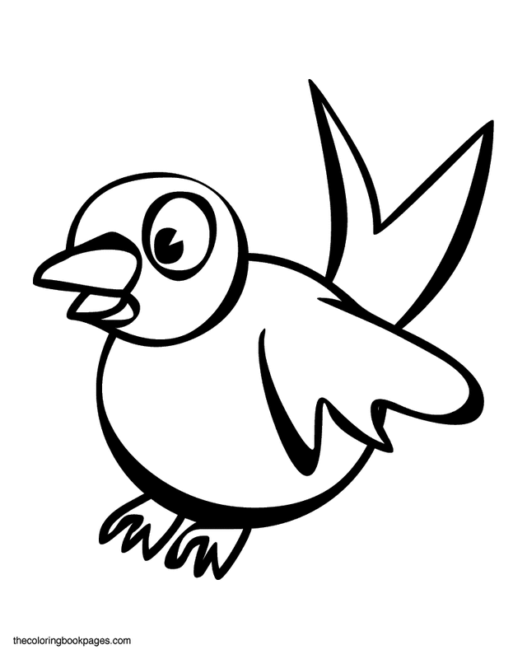

Can you \_\_\_\_\_\_\_\_\_\_\_? 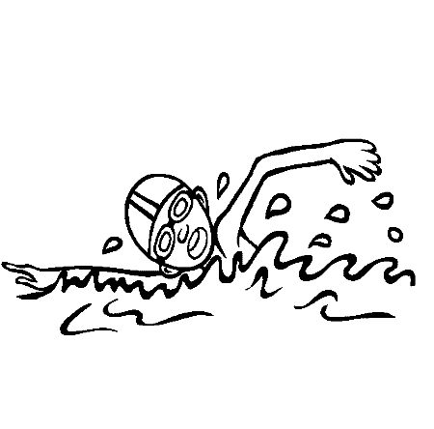

**Do you have a \_\_\_\_\_\_\_\_\_\_\_?**  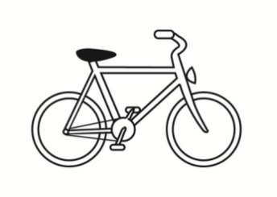

**Is she a \_\_\_\_\_\_\_\_\_\_\_?**  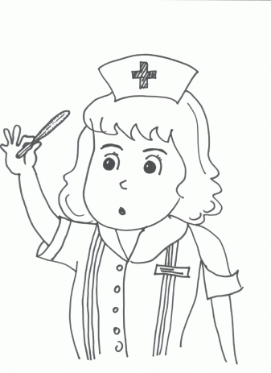

**I’m in the \_\_\_\_\_\_\_\_\_\_\_.**  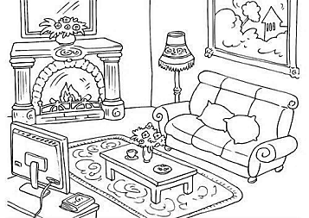

**We can’t play outside on a \_\_\_\_\_\_\_\_ day.**  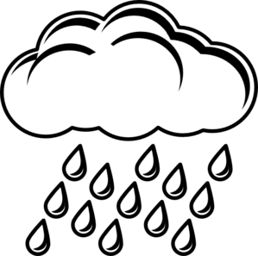

臨摹抄寫外觀單字

tall

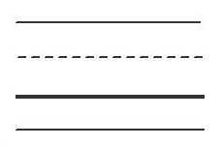

fa**t**



 bird

 O.K.

Japan



 dance

play



lunch

|  |  |
| --- | --- |
| Lisa | **name is My Lisa .** |

|  |  |
| --- | --- |
|  | **What time is it?**  **four It’s . twenty** |

|  |  |
| --- | --- |
|  | **Can you sing?**  **can I , Yes .** |

|  |  |
| --- | --- |
|  | **How’s the weather?** |

|  |  |
| --- | --- |
|  | **How do you feel?** |

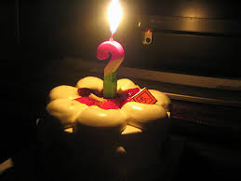

**old How you are ？**

